Life’s a doodle
Contents
1. The Blitz at Swansea 1941 3
2. Scouting – Preparing for Queen Scout 4
3. Steel Company of Wales BOS plant 5
4. 3M Company Gorseinon 6
5. BP Chemicals Baglan Bay 7
6. Ostreme Festival. The Bells of Santiago 8
7. Forties Field North Sea Oil 9
8. Offshore Construction 10
9. Opening the Forties Field 11
10. Balmoral cricket 12
11. The Red Push-button 13
12. Qatar Road to Dukhan 15
13. Abu Dhabi Maqta Bridge 16
14. Das Island 17
15. Fishtail Lodge Pokhara Nepal 18
16. Mitre Peak New Zealand 19
17. Stavanger 20
18. Aberdeen Dyce ERC 6 July 1988 21
19. Scotland Woodhill Lumphanan 22
20. Kuwait Mina Almahadi Refinery 23
21. Sea Empress Milford Haven 24
22. Bechtel Jamnagar India 25
23. Bab accommodation and mosque Abu Dhabi 26
24. Oman Muscat 27
25. Houston Texas 28
26. Al Dabbiyah Abu Dhabi 29
27. Jebel Dhannah 30
28. Dasman Institute Kuwait – a nurses’ story 31
29. Egypt 32
30. Shanghai 33
31. Dusit Thani Hotel Dubai 34
32. Worms Head 35

The Blitz at Swansea 1941

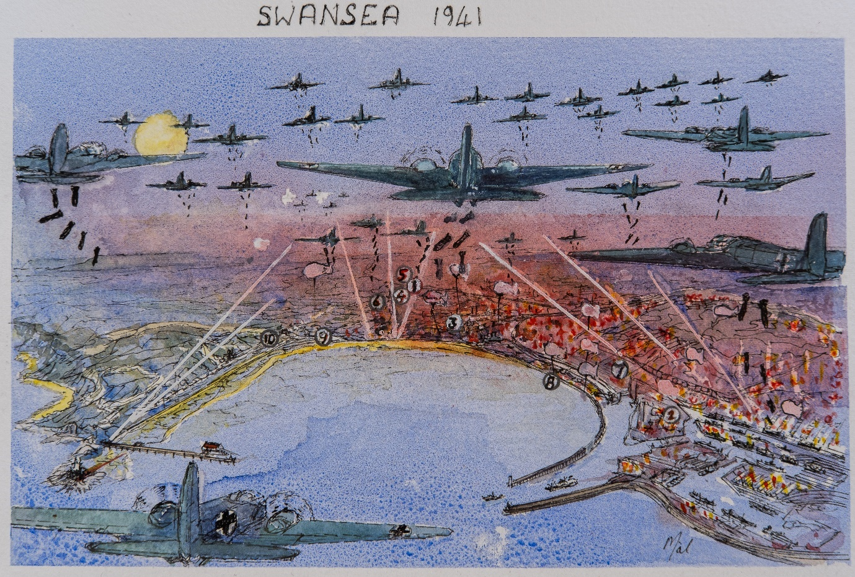

- Born at 3 Kings Head Road, March 1942.
- Dad worked at the Prince of Wales Dry Dock.
- Cwmbwrla First Primary School. Lived at 145 Middle Road.
- Gendros Junior School. Lived in Penlan.
- Home 19 Tudno Place, Penlan.
- Dilwyn Llewelyn Secondary School. Lived in Penlan.
- Swansea Secondary Technical Schoolc
- 24th Swansea Sea scouts. Lived in Penlan,
- Swansea University. . Lived in Penlan.
- Oystermouth Ostreme Festival 1973. Live at 37 Worcester drive Mumbles
Education
- First Job, English Electric, Leo Marconi – 1964 1966, Kidsgrove, and Chelmsford.

Scouting – Preparing for Queen Scout

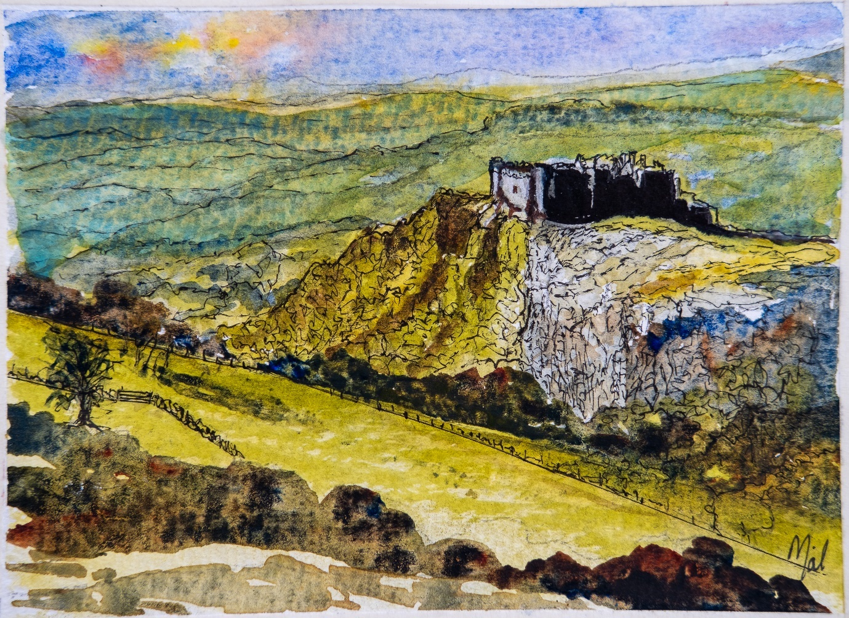
Sept 1958
A group of venture Scouts left Swansea one Saturday evening journeying by bus to a remote road North of Ammanford in the Brecon Beacons. We set out along a small track over the Black Mountain towards Carreg Cennin Castle. After an hour we stopped and made a hot drink and again headed off towards the castle. An hour later we saw a distant light thinking it was a farm near the castle. When we arrived at the light, we realized it was a torch that one of us had left behind by mistake at the previous stop. After that little setback we set our compass to the map and kept on a new path until we met a road some hours later. The road led us to a barn near the farm that we had been looking for. The hay in the barn was warm and inviting so we climbed into the hay for some well-earned sleep. We arose very early In the morning to avoid the farmer and set off along the track shown in the doodle to explore the castle.

Steel Company of Wales BOS plant

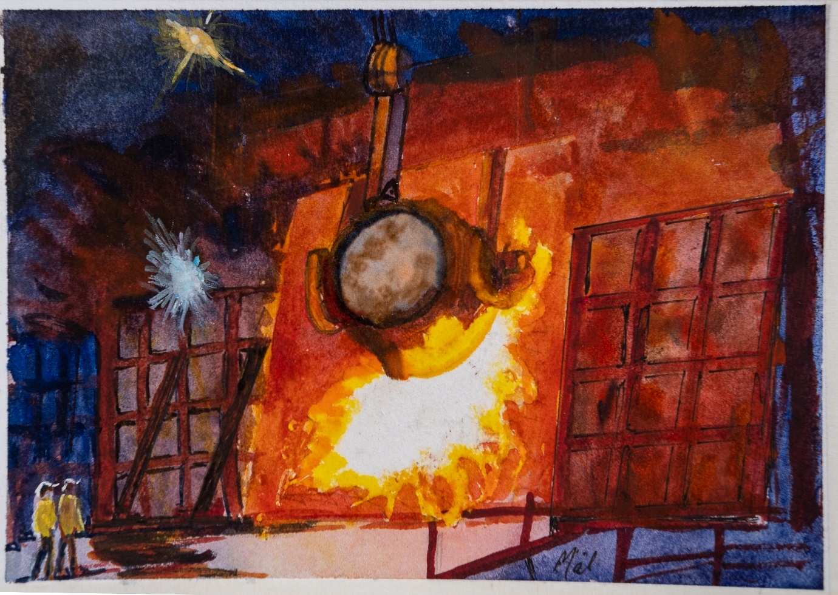
Charging the Basic Oxygen Steel plant and taking steel samples for analysis. Sept 1966
In 1964 I helped build KFD 9 computers at English Electric Kidsgrove, which is near Stoke on Trent. Every day a bus journey took us from the centre of Stoke through its villages to our factory at Kidsgrove.
The Met Office Computer was my first project, this took up the space of an average kitchen, it cost some £2 million to manufacture. I remember carrying a single block of 4k, 48-bit core store that cost the same price as my first house (£4000). Here I learned binary, to program in machine code and count in Hexadecimal. After a year I was sent to Marconi at Chelmsford where I joined the design team for the Hardware of the Myriad II Computer. I returned to Swansea the following year and bought a house overlooking Swansea Bay in the Mumbles. At this time, I worked for the Steel Company of Wales at the Abbey Steel Works Port Talbot. My job here was to develop the software to analyse the content of steel samples every minute.

3M Company Gorseinon
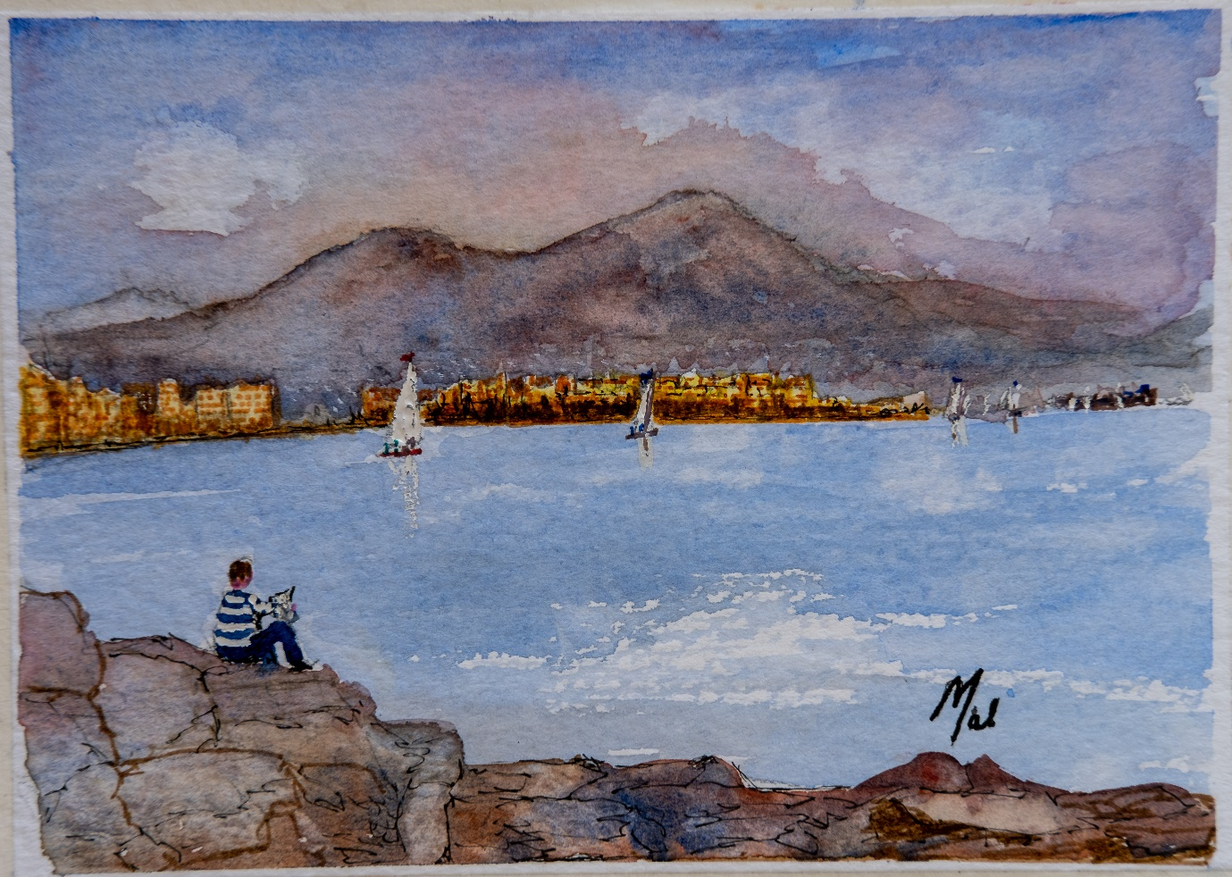
Vesuvius from my Naples hotel window, during a 3M marketing conference. Nov 1969

After two years in the Steel Company I joined 3M at a manufacturing plant in Gorseinon as a Technical Service Engineer. This job took me around the UK and to Sweden and our sister plant at Caserta in Italy. On my first visit I arrived at the hotel late one evening. When I arose in the morning, I pressed a button on the wall next to my bed that lifted a massive shutter giving a magnificent view of Vesuvius. I spent 3 months travelling to sites in Italy. I climbed the steps of the leaning tower of Pisa, visited Venice, Rome, Sienna, Milan and Florence. We had 3 days in Florence to explore, there was so much to see I hardly stopped running between the amazing sites.
3M organised a wonderful marketing dinner in Naples where the steaks were brought in on trays at shoulder height flaming in brandy and modelled on Mount Vesuvius. On another evening at dinner in Umberto’s restaurant in Naples I met one of the marketing team who was a trained opera singer. A short time later a group of film makers came into the restaurant
and took up a large table. Their singing entertained everyone while they waited for their meal. When it arrived our opera-singer sang an amazing aria. The film makers all responded accordingly which led to an unforgettable experience at Umberto’s.

BP Chemicals Baglan Bay

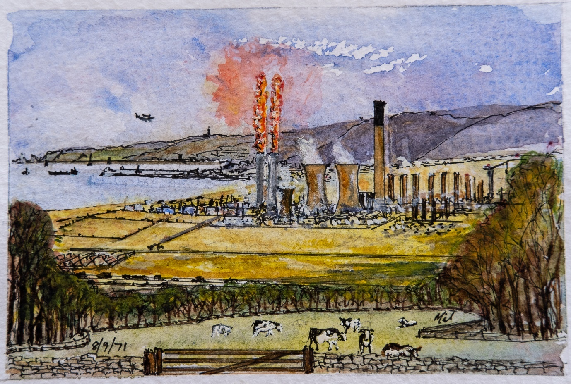

Baglan Bays’ the place to be said BPCI ad’ recruiting staff for a massive project. June 1970
While in Naples I saw a headline in a British Newspaper ‘Baglan Bay’s the place to be.’
BP Chemicals Industry was recruiting staff for the largest chemical plant in Europe.
I joined BPCI to develop a message switching system that would integrate process computer and terminals throughout the plant to send information to a central ICL data processing centre. The plant flared ethylene for months which lit up the night sky while it was being commissioned. On the day that Prince Charles was due to open the plant a helicopter from the news channel flew over the site. Unfortunately, an explosion occurred in a cold box located high above the plant. This release hydrogen that burned throughout the day. There were many incidents over the years that affected local residents and schools. One day a pressure release disc burst, releasing white polyester particles into the atmosphere. A colleague came into the office as if he’d been covered by snow. Another time a release of chlorine occurred as we drove to work. The roads around the plant were all closed down and the local school was evacuated. The plant was originally built on an area of sand dunes. All the housing and schools came years later; planning permission did not seem to account for the risks associated with the industry. The plant has now been totally closed and the site cleared and reused by other industries.

Ostreme Festival. The Bells of Santiago

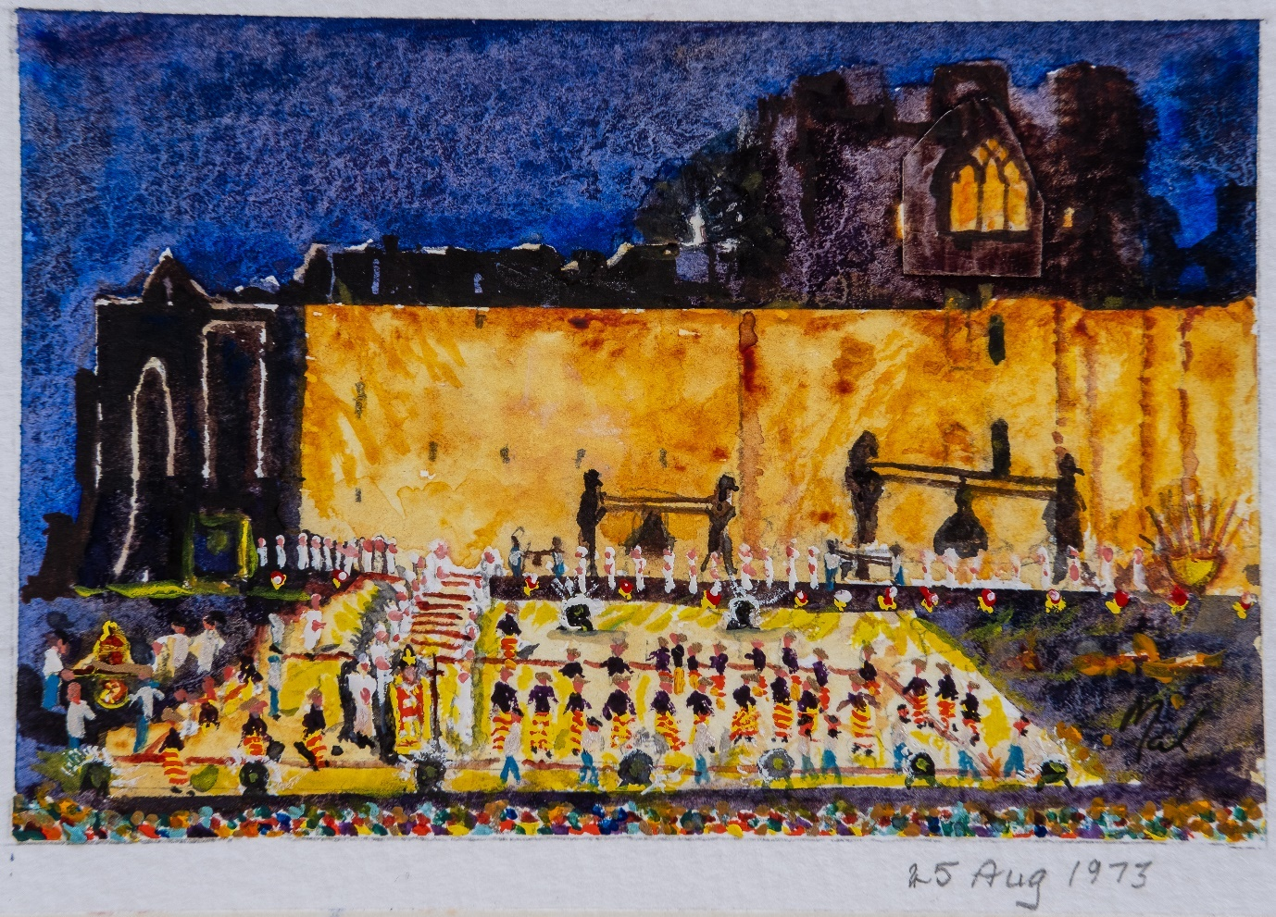
Excess cable, floodlights and community effort produce a son-et-lumiere at Oystermouth Castle.
In 1970, the people of Oystermouth which is near Swansea were challenged by Evening Post reporter Paul Chambert to produce a pageant of the history of the village. There was an amazing response and over the next 3 years, virtually everyone in the village set about producing a 9 day festival called OSTREME. I had the privilege of working with a group of colleagues as Sectrtary for the project. The doodle shows a son-et-lumiere staged in the moat of Oystermouth castle. The floodlights and 25 ton of electrical cable came from project waste at BP Chemicals at Baglan Bay. The music and script were composed locally to tell the story of three bells that were hanging in the local church. The Bells had been recovered from a tragedy that befell a Church del-la Campania in Santiago Chile. In 2010 the bells were returned by the Royal Navy to their origin home.
The Ostreme project lasted 9 days with days for Maritime events, History of the 13 church denominations in Oystermouth, History of the Castle with events that led to the signing of the Magna Carta and a military day attended by Lord Nelson who lived in the next village.
When we first presented the programme Tim Perkins remarked all you’ll need to see everything is two weeks holiday and a bicycle.

Forties Field North Sea Oil

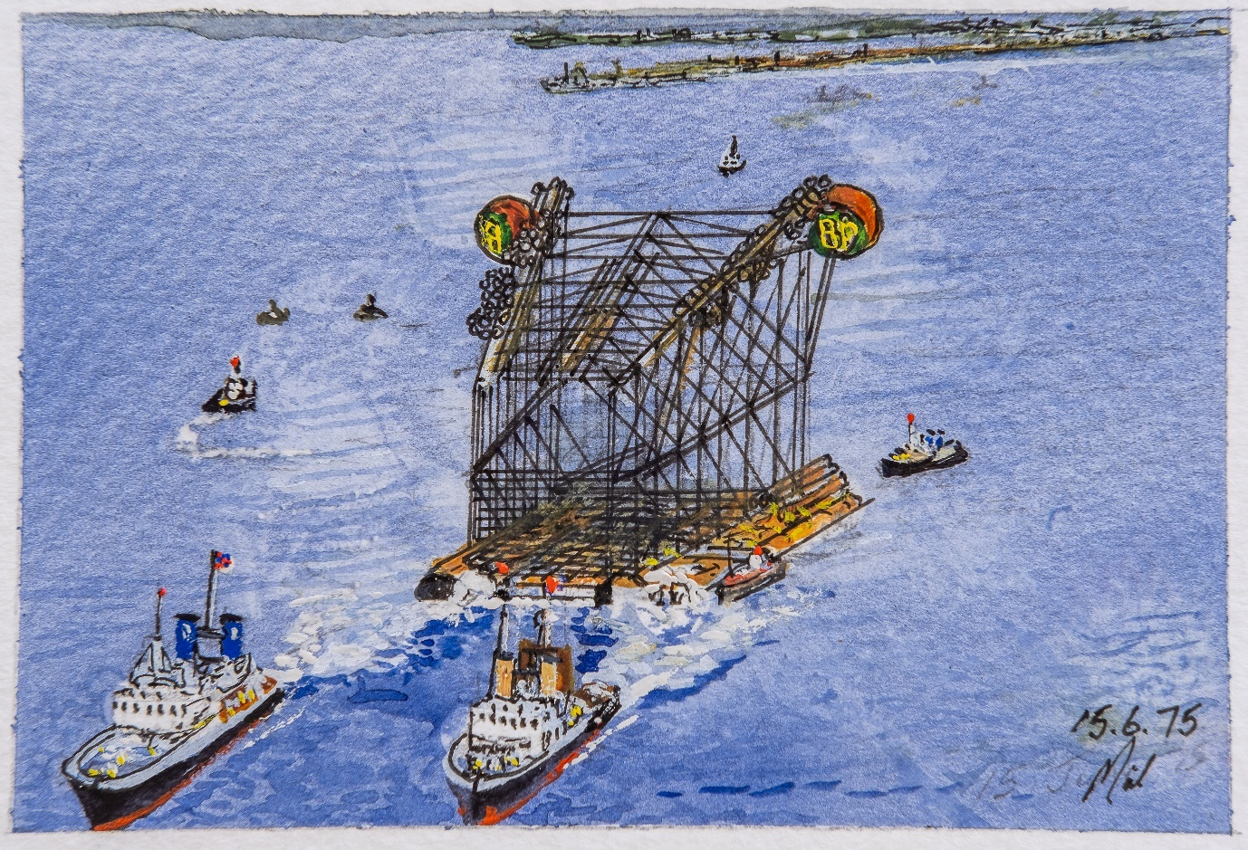
Snow on my 1st June arrival in Aberdeen, two weeks later the Forties jacket was towed out.
The Forties Alpha Jacket was towed onto location in 1976 two weeks after arriving in Aberdeen at BP Exploration’s Dyce headquarters. There was great excitement as we listened to the offshore radio from the communication engineers’ office. Once on location, sections of the jacket were flooded in sequence and the jacket slowly turned upright over the spot where the wells would be drilled. The Nova computer used to control the flooding sequence failed before completing the programme.
An engineer was lowered by crane into a hatch at the top of the jacket that gave access to a local control panel. He completed the remaining steps of the sequence manually to finalise the installation process. Sometime later, that same engineer was killed when a helicopter’s tail rotor blades hit the cable of a crane as it attempted to land on the crane barge Hercules. The tragic response that followed was an introduction to ‘Emergency Response’ that was to last the rest of my life.
Some years later the Nova computer was scrapped when it came into our stores. I still have the motherboard hanging in my studio. The 4k core memory is a handwoven masterpiece.

Offshore Construction

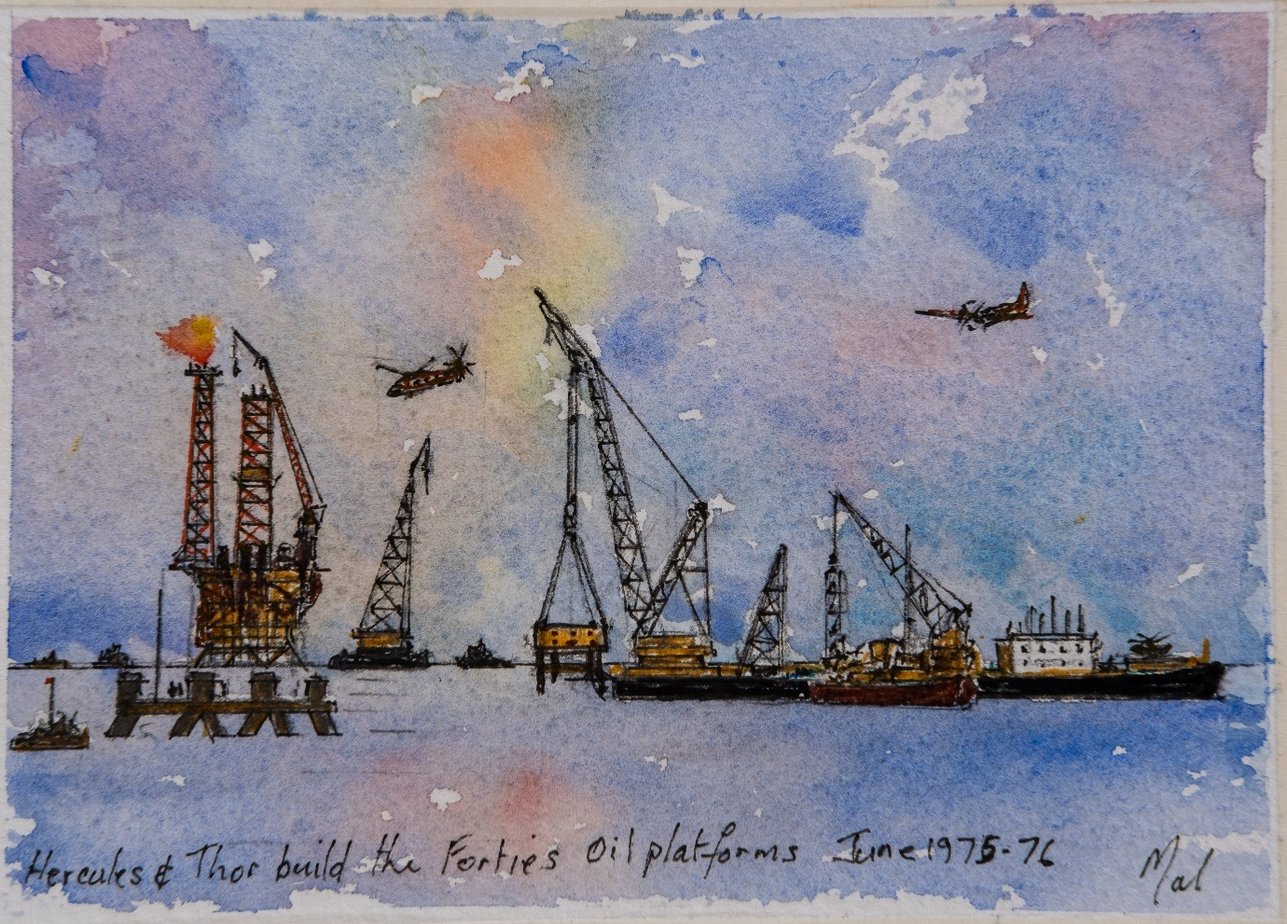
I’m sent to rewire an offshore control panel for Forties Alpha so that oil production can start
The Forties platforms were assembled in modules. The crane barges Hercules and Thor could lift more the 20,000 to modules and place the accurately on a pinhead. When the assembly was complete, we had to test our telemetry control system which was designed to operate from a control centre at BP Explorations’ headquarters in Dyce over 150 miles away.
The control system was designed so that the platform could be run unmanned. Previous attempts to unman a gas platform led to an undetected fire that almost destroyed the platform. The plan was to test thousands of controls before start-up
Nothing happened when we tried to test the first production well on Forties Alpha. We could not start up production unless the telemetry was operational. I was sent offshore to resolve the problem. There were 36 wells on each platform. It turned out that the pipework to the wells had been numbered 123 456, for each of six wellhead compartments. The cabling drawings had been numbered 135 246 so many of the wells were wired to the wrong control equipment. It took all night to rewire the hundreds of cables required to match the instrumentation. A few weeks later HRH Queen Elizabeth II was invited to press the start button for Forties Oil Production.
The test separator was built for a maximum flow of 10,000 barrels per day. When production started the first well flowed at 30,000 bpd. The field was designed for a life of 25 years. It’s is still producing oil and gas 50 years later.

Opening the Forties Field

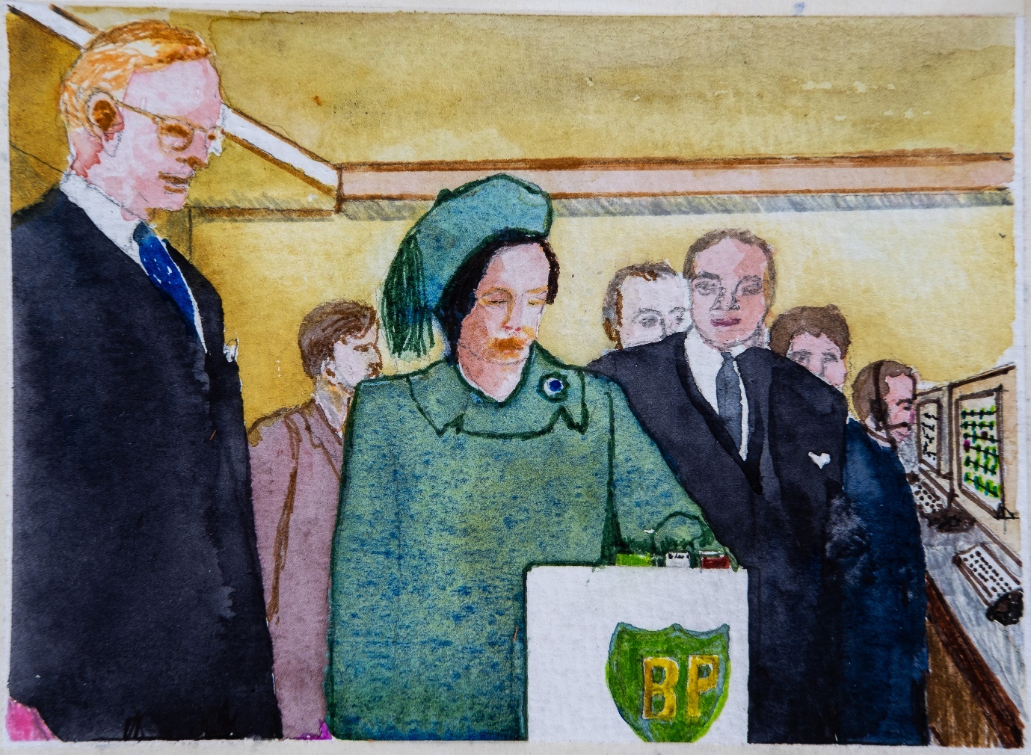
Just before the Queen pressed the Forties start-button there was an emergency alarm. 3rd Nov 1975
Having been tasked with designing a push-button for Queen Elizabeth, I was advised to adopt the KISS principal. (Keep it simple stupid). So, there was a red light and a green light, initially the red light was on to show everything shutdown. When the silver push-button was pressed the green light came on and a signal sent to the controlling computer that can be seen in the doodle.
Prince Philip noticed two magenta valves on the pipeline display. we felt that he was incredibly astute! We explained the communications between these valves and the control centre when the Scottish Independence movement exploded two bombs at these sites. Shortly before the Queen was due to press the silver button another alarm came up showing a new valve had lost communications. The queen was told to delay the ceremony until we investigated. The valves are in remote locations and the first police car could not find it. A technician was sent by helicopter and immediately found the problem. A farmer had been clipping hedges near the valve site with a rotary cutter attached to the tractor. He inadvertently cut through the cable causing the signal to fail. A message came through to the control room and her majesty was told the problem had been resolved. She immediately pressed the silver button. Unfortunately, the television crews had not been informed so the nation did not witness the actual moment. Fortunately, the television crew had a camera running all day from an adjacent office. This contained the vital footage that was edited into the six o’clock News bulletin.

Balmoral cricket
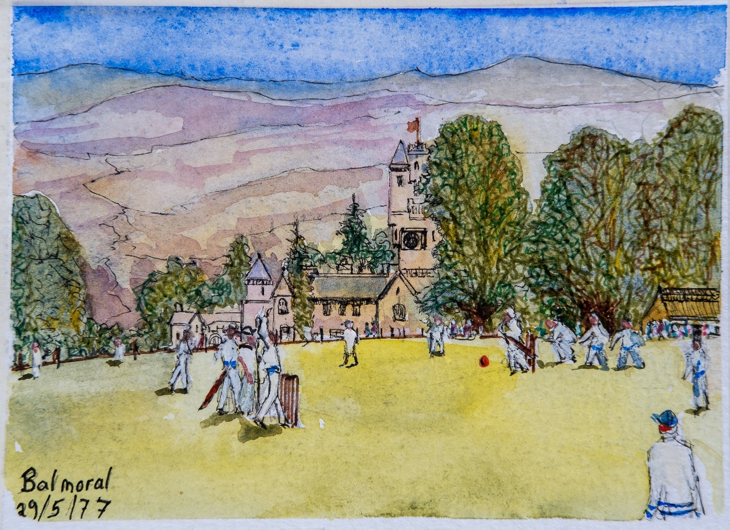
We played lots of cricket in Scotland, including games at Balmoral with the queen present.
BP’s cricket team reached the semi-final of the Aberdeen District league cricket cup.
A few days before the event our main fast bowler was sent offshore for three weeks, so I asked the contractors in our office if one of them would play in the semi-final. The best response was “Ask Marline Dick in the Forties office, she’ll play for you she’s better than any of you lot. She’s had a trial for England’s ladies.” I said “look I want to know by Wednesday which of you will play. Make your mind up or there will be trouble.”
I challenged them again on Wednesday, to which I received the response – “Look we’ve told you what to do ask Marlene.”
So, I called the league secretary and asked if we could play a lady in our team in the semi-final.
He told me he didn’t know. However, there was a league meeting that evening a so he would ask.
He duly called back next day and said everything would be OK because two ladies had played in last years cup. However, I had to submit her completed registration forms by next day. I drove over to the other side of Aberdeen, collected the forms and went to see Marlene in The Forties Office. It was a huge office, I was told Marlene was over by the photocopier. She confirmed, when asked that she was indeed Marlene Dick. I wasn’t sure because she looked as if she could have been a Vogue model. I said “ Would you play cricket for us on Saturday – “It’s the semi final of the Cricket League Cup”. She replied that she would love to play. I explained there was only one problem, she had to complete the registration forms. She took the forms, and duly filled them in. She said “ the only thing is, I’ve never played cricket before in my life”

The Red Push-button
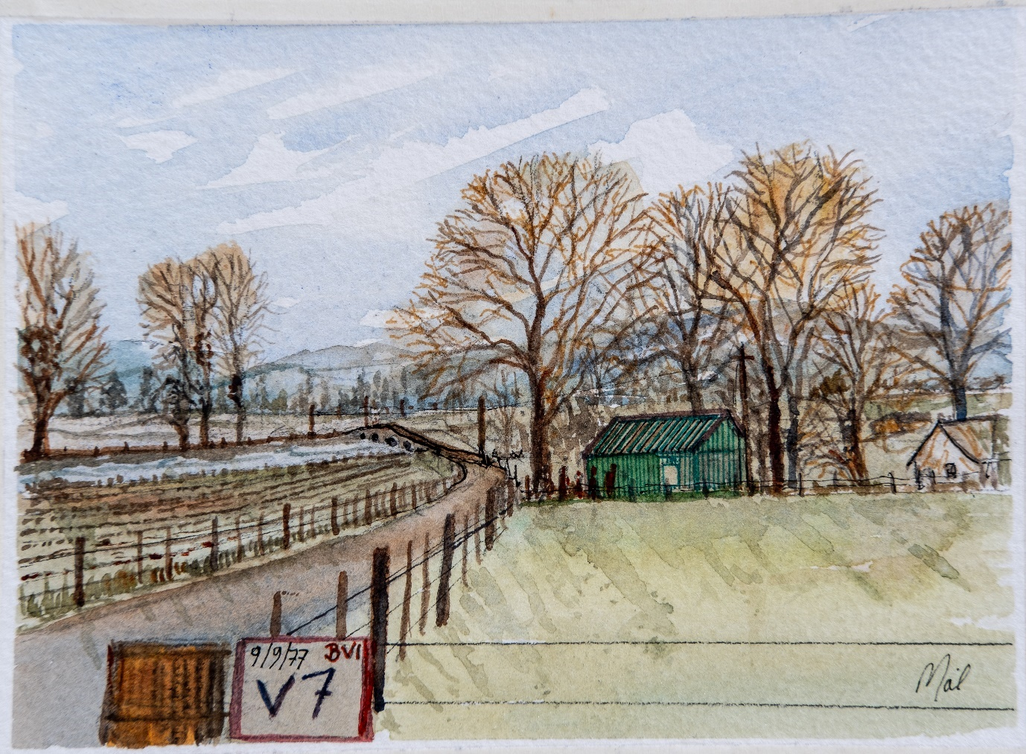
My worst incident occurred at Valve site 7 where we shut down oil production for 24 hours. 9/9/77
It was 9th Sept 1977 when the worst incident I was to be involved with occurred. I was confronted by a production operator as I entered our pipeline control room. “Your clowns (my technicians) have shut down the Forties Pipeline,” I was told – 500,000 barrels of oil per day is being lost.
I had two new technicians who were sent to valve site 7 to replace a modem that sent the control room signals to the pipeline shut off valve. The job was quite simple. Turn off the power, unplug the old unit, replace it with a new one. I explained to them very carefully that if the shutoff valve started to close the only way to stop it was to press the red push-button on the side of the valve. As soon as the new modem was in place, I would be able to talk to them over the speech facility in the modem. The technicians also had radios but these had poor reception at valve site 7 as they had to communicate via an operator from Buchie with a very broad Scottish accent.
The control room supervisor Jim, (a very cool character), saw me enter the room and called me over to the main console. Jim asked me to check the procedure he used was correct to open the main pipeline isolation valve at the Cruden Bay Pumping station, so that he could restart production of the four offshore platforms that fed the pipeline. I confirmed his procedure was absolutely correct, however the isolation valve did not open. When my technicians first arrived at valve site 7 they took out the old modem, replacing it with the new one. Turning the electrical power back on, to their horror the shutdown valve began to close. Later, I asked them why they didn’t press the red push-button to stop the valve closing. They told me that they could not find a red push-button. There was only a green push-button. As their radios were so poor, one of the technicians drove to a telephone pay-phone two miles away and called the control room. He spoke to the switchboard operator who was very busy. Putting his money into the payphone he asked to talk to the control room, where I was sitting with the supervisor. He was told that the control room line was busy and he would have to wait. He kept waiting until his money ran out, so he asked the operator if she would accept a reverse charge call. She told him she was not permitted to do that (against company policy – which changed next day), so when the money ran out, he went back to the valve site. The other technician told him that the valve closed and automatically opened again. It then started to close again. When it opened the second time, he pulled the fuses out and stopped it from moving. There was nothing else they could do so they drove off to a local pub and had lunch.
When the valve first closed it sent a massive pressure pulse back up the pipeline. The system was designed to have an emergency shutdown valve at Cruden Bay so that if ever the pipeline was blocked it would relieve pressure into two very large holding tanks to prevent over pressurizing the sea-line and possibly rupturing it. The oil from the sea-line diverted into the holding tanks and the gas in the oil was burned off in about twenty small flares. Unfortunately, grazing in the field next to these flares was a herd of some 200 cows. The intense noise and heat from the flares started a stampede, the cows running through the town at Cruden Bay causing havoc. The farmer and townspeople as well as all the managers on the offshore platforms called the Control Room. That was why the line was busy and my technician could not get through.
Back in the control room we tried again to open the big shutdown valve, it still did not open. I called the Cruden Bay technician to ask him to see why it had not opened. He volunteered to use the manual switch to open the valve. However, that also failed so I asked him to go to the valve and see what was happening. He told me that he could hear the valve motor running but the valve was not opening. By this time, I’d called the Instrument Engineer and asked how the motor could be running and the valve was shut. He told me the valve gear box must have been stripped – a big problem. The valve would have to be replaced.
The technician said that the big shut off valve was the only valve on the site that was underground. It was getting on for 4.30 pm on a Friday bank holiday and everyone was starting to go home. Over the next few hours, they dug out the valve and tried to lift the valve gate using a 12-ton crane. However, the gate was well and truly stuck. The Forties crude is a very waxy oil and when the valve slammed shut for the very first time the waxes must have melted and glued the valve shut. We decided that we might have to replace the valve that would have to come from the South of England overnight. When the engineers looked to undo the valve flanges, they found that the valve had been welded directly into the line. The valve came with two flanges the same size. Unfortunately, the landline was six inches larger than the sea-line. In order to keep the project on course they must have decided to weld the sea-line directly to the valve and bury the evidence. If we had, had to cut the sea line to replace the valve it would have meant filling the line with water and hydro pressure testing. They decided to use a bigger crane and by midday Saturday the larger crane managed to lift the valve gate. We had lost 24 hours production.
At the investigation the technicians showed me the circuit boards from valve site 7. The circuit chips had exploded and the printed circuit lifted. The telephone to the site had been struck by lightning. The Pipeline had cathodic protection so there was a small difference in the paths to earth. This caused a massive voltage to blow the control circuits and trip the power. Without the control circuits the valves continually circulate from open to closed when the power is restored. Finally, we all went to Valve Site 7 to see the red push-button. There was a sign on the gate as we arrived – ‘BEWARE WET PAINT’. The contractor had been told to paint everything on site green. The Red push-button was now green. When we finished the investigation, we found there were at least 20 small events that all came together in sequence to cause the incident. It’s always the ways with incidents.

Qatar Road to Dukhan
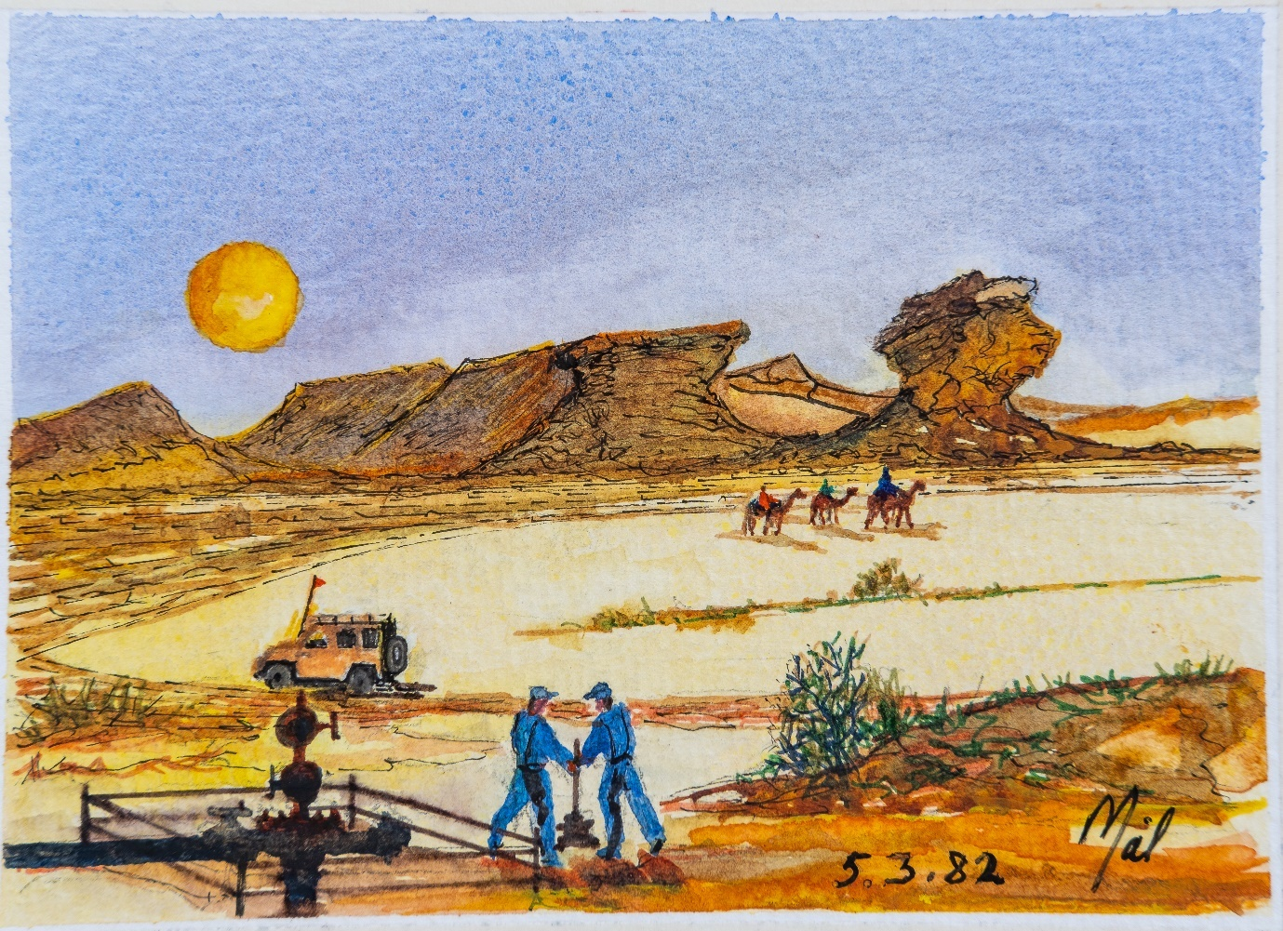
The road to Dukhan in Qatar passes through some spectacular windswept sculptures.
Having completed five years in Aberdeen I relocated to our London HQ and was sent on my first overseas assignment that to me to Dukhan in Qatar. I led a team of researchers that to install a novel rotary oil and gas separator. The doodle shows a desert wellhead on the road to Dukhan. The separator was installed some 30 miles away at Jalayah. One night after completing tests at Jalayah I drove to the gate to be stopped by a security guard to be checked out. He said “matches, matches.” replied “no matches” I don’t smoke and drove past. On leaving the site, the lights on our rig could be clearly seen for miles. Having turned my car around I drove back to switch them off, the security guard stopped me entering again challenging me about matches. We had a brief exchange of words and I again drove past him up to our site and turned off the lights. On returning to the gate the barriers we now firmly shut. On winding down my car window, he placed his rifle into my face signalling to get out of the car. We proceeded to walk down the desert road away from the site. Me with my hands in the air and a rifle in my back. The guard kept saying Sayara, Sayara. Suddenly, a car came over the horizon towards us headlights blazing. My arms were waving furiously to slow it down. It was the night shift coming to work. What’s going on they asked. Replying, I said “he keeps saying Sayara, I’ve no idea where we are going.” It turned out the guard’s car had broken down in that morning. He knew I was and engineer, so he wanted me to fix his car. (Sayara means car).

Abu Dhabi Maqta Bridge

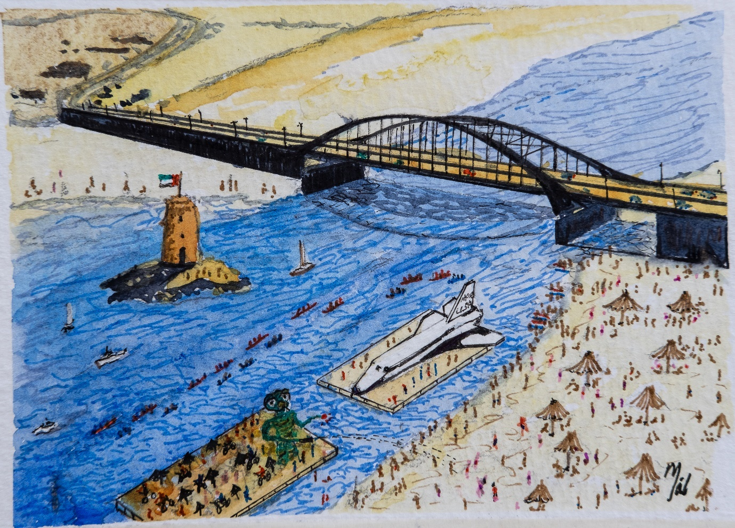
ET was our entry for the raft race. Our main rival was a full-scale model of a space shuttle. Feb 1988
This was the entry to Abu Dhabi city from the rest of the Emirates. A site near the bridge staged the Abu Dhabi raft race. During the day there were many raft races for companies throughout the city. Companies also built large rafts which were towed around during the day. One raft was an exact replica of the Space shuttle. It was so convincing, the shuttle had been reported as having crashed in Abu Dhabi from an over-flying aircraft.
We built our raft welding together several hundred oil barrels on Sadiyat Island, so the raft had to be towed to the site. It was built to just pass under the Maqta bridge with less than a foot clearance. The raft depicted Stephen Spielberg’s film ET. The deck contained six bicycles and a series of black umbrellas. ET was built 5 barrels high and 2 barrels wide with the head constructed in fibre class. Altogether it was almost 20 feet tall. He had long arms built from scaffolding poles through which water flowed into hose pipes that projected from the hands. ET firmly rejected a competitive speedboat that tried to ram us thinking he was built of polystyrene.

Das Island

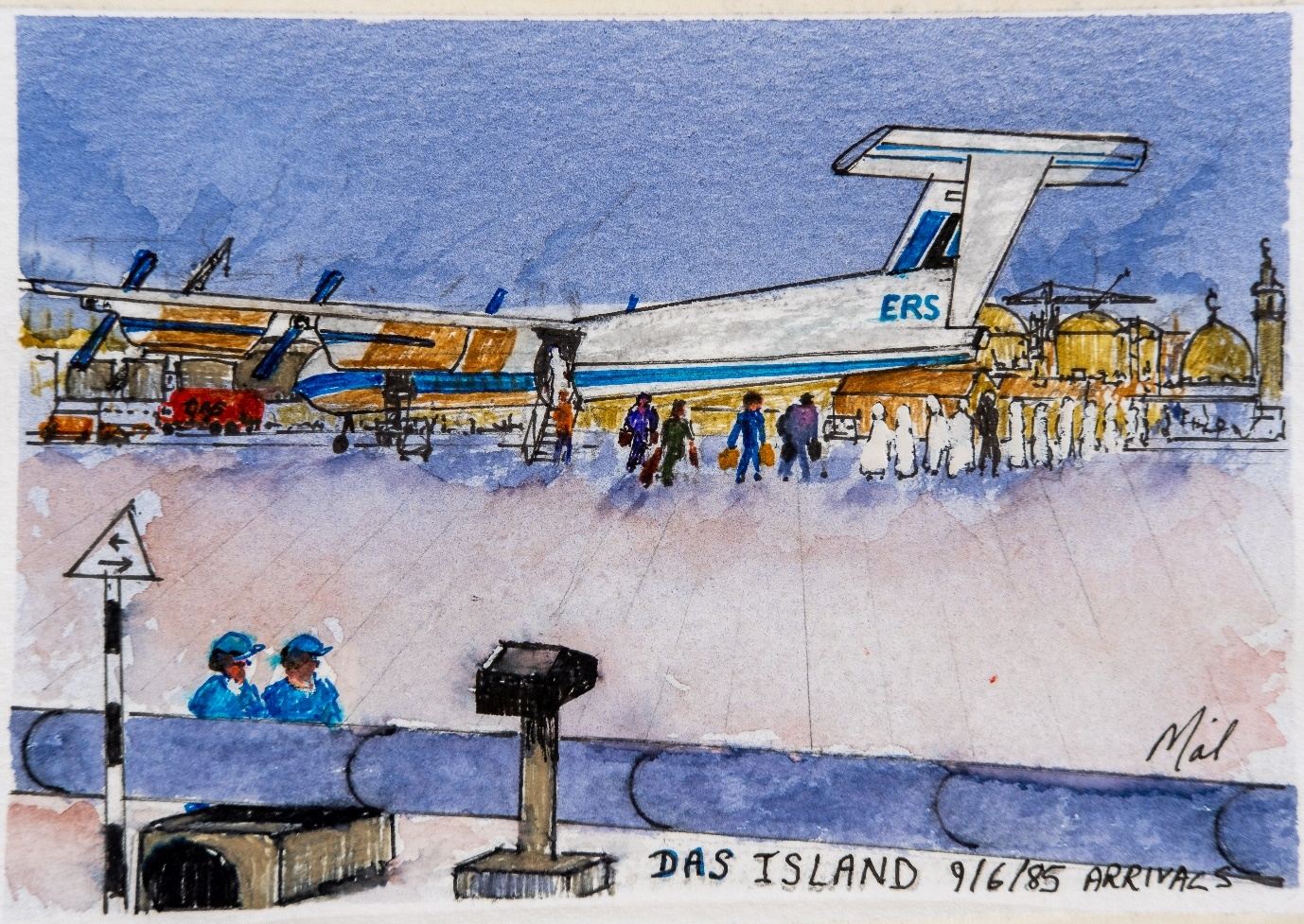
My last project in Abu Dhabi was to specify a distributed control system for Das Island.
Das Island was a terminal that collected oil production from three super-complexes in the Arabian Gulf. Offshore oil and gas was processed on the island and shipped around the world on oil and liquid petroleum gas tankers. A flight from Abu Dhabi took about an hour to reach Das Island. Before my first visit I met Charlie Bedwell a communications engineer who first visited Das Island when there was nothing but birds on the Island. BP installed a Tropo Scatter Telecommunication systems to provide multi communication channels with Abu Dhabi. The same system was used to communicate with the Forties field. (This was before the availability of Fibre Optic Cables.)
BP’s London office investigated the loss of oil reported from Oil Tankers on their journey to the UK. The explanation given was a loss of gas vented during the long journey. Years later Sheik Zayed was given a lavish visit to Egypt by his oil minister Dr Khruba, who provided his personal 747 aircraft and all the luxury of the visit. Sheik Zayed thought ‘How much am I paying this man?’, so he set up an investigation. It was reported in the newspaper that the final fiscal oil measurement meter at Das Island had been tampered with and that Dr Khruba had been taking 10% of the oil that was shipped.

Fishtail Lodge Pokhara Nepal

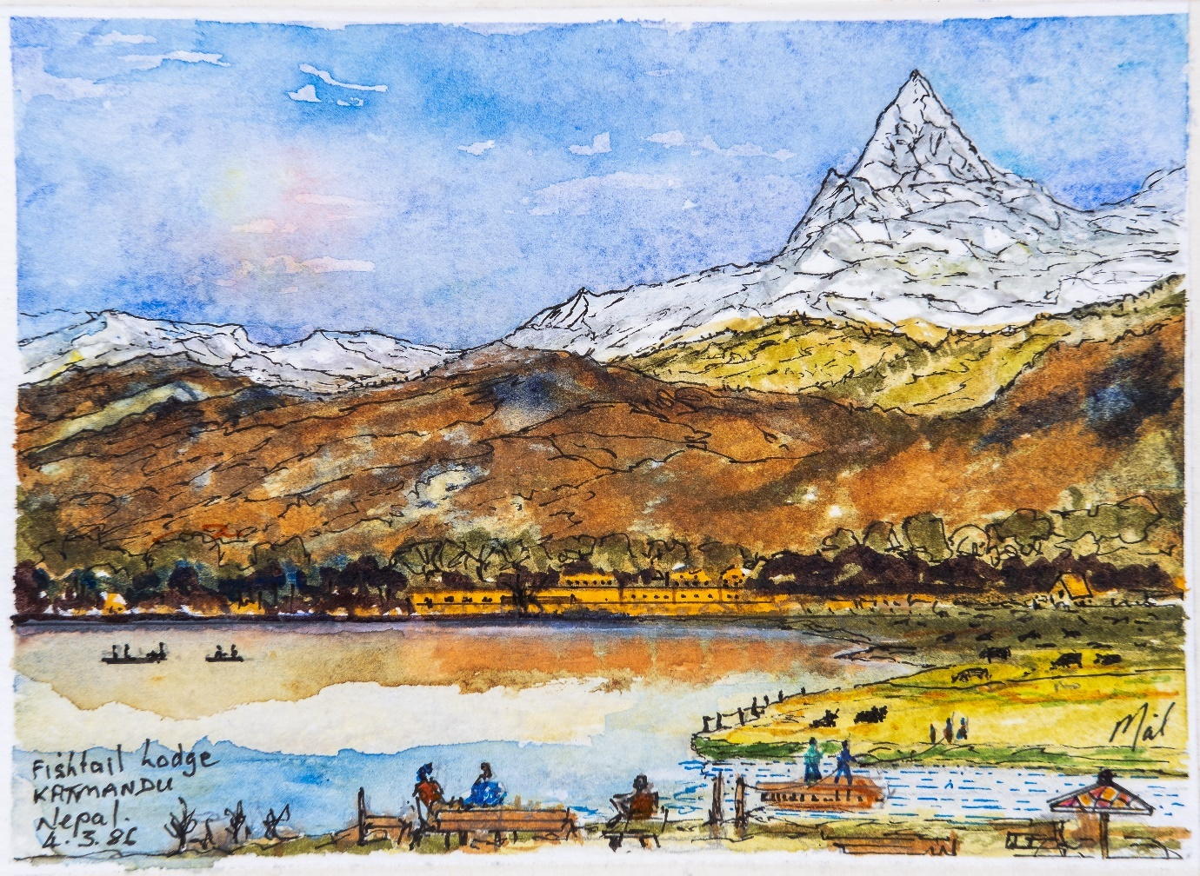
Summer break, a trek through the Himalayan foothills. A school gift of 50 coloured pens was magic.
One of the great things about living in Abu Dhabi was the opportunity to travel during the holidays. We visited Fishtail lodge in Nepal and trekked to Annapurna base camp. Fishtail lodge was located on a small island overlooking Machapuchare, which is a mountain situated in the Annapurna mountain range of Gandaki Pradesh, north-central Nepal. Its highest peak has never been officially climbed due to the impossibility of gaining a permit from the government of Nepal.
Our trek, accompanied by 6 porters, took ten days through villages and tea houses along mountain tracks. We crossed several rope bridges and stayed in tents or mountain hotels. The separate room was 2 rupees. A porter in the party in front of us had a small cockerel tied to the top of his rucksack. The bird flapped and squawked all the way until we reached a farm at the top of a wooded hill. The almost featherless bird was released amongst more than 50 hens, I couldn’t help feeling how overawed he was by his situation.
The trek was an amazing experience, we would go up, and then come down repeatedly to acclimatize to the height. You could get ‘Eagle’ beer from porters at over 10,000ft. We finally returned to Pokhara, a city on Phewa Lake, in central Nepal. It’s known as a gateway to the Annapurna Circuit, a popular trail in the Himalayas. The doodle shows small boats visiting the Tal Barahi Temple, a 2-story pagoda that sits on an island in the lake. We returned to Katmandu where my wife ‘Nise’ played On top of the world on a trumpet borrowed from the Yak and Yeti hotel band

Mitre Peak New Zealand

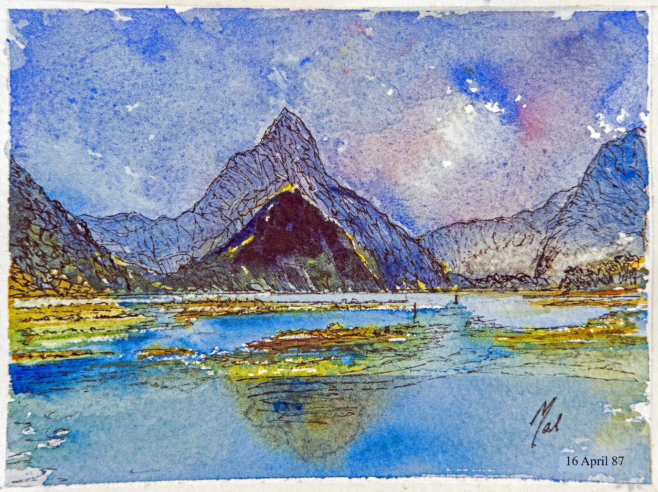
Easter break provides a visit to Perth Australia and New Zealand’s North and South Islands. 16/4/87
Another holiday took us to New Zealand via Singapore and Perth in Australia. I was interested in the possibility of a job at Massey University. However, that did not transpire, but my wife was offered a job making artificial eyes at which she was particularly skilled. We spent the first week of our holiday travelling the South Island. The doodle shows Mitre Peak a particularly beautiful spot. As we journeyed North on a Sunday morning, ‘Nise’ took a turn at driving. We drove through a small village as we approached the ferry from Picton to Wellington onto the North Island.
We were flagged down by PC Rigsby who told us that we were breaking the speed limit in an LSZ. Writing out a ticket he asked us for our address. We told him we lived at PO Box 303 Abu Dhabi. ‘No one lives in a PO Box’ PC Rigsby exclaimed. We explained that virtually everyone in Abu Dhabi has a PO Box. When we asked what an LSZ was we were told it was a Low Speed Zone, the fact we didn’t have those in the UK was irrelevant. We were told to go and pay a fine before leaving the South Island at the court at Picton.
When we reached Picton, the Ferry was about to leave so we boarded it and travelled to the North Island to continue a wonderful holiday. Before leaving New Zealand we reported to Police headquarters in Aukland to pay the fine. When the sergeant at the desk saw that ‘Nise’ was from Cranleigh in Surrey he sent us to the top floor to see the Chief of Police. The chief was from Cranleigh in Surrey and so they reminisced a while. He felt the fine was over zealous and voided it.

Stavanger
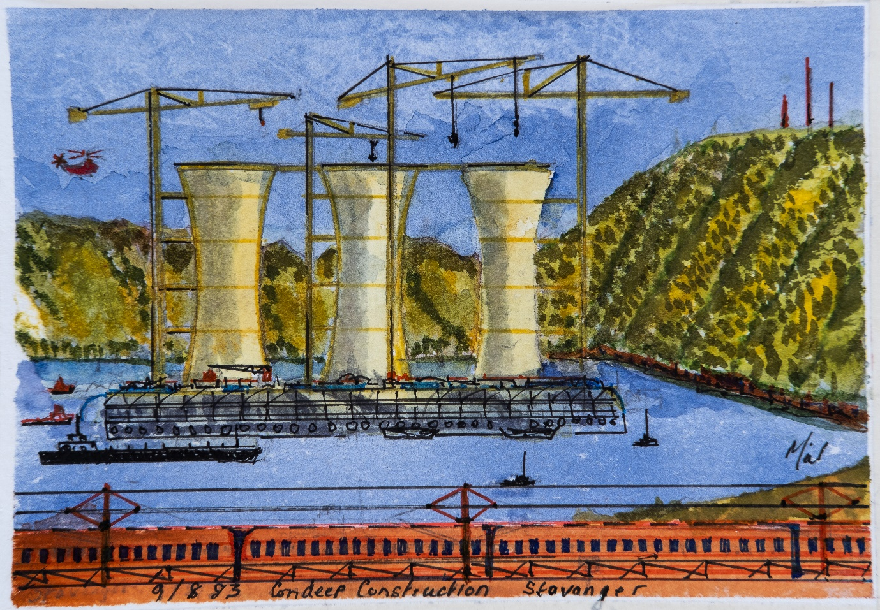
An urgent call from London mean’s that I never did make that cruise I booked to see the fjords.
Our offices in Norway were located near a fjord where a Condeep oil and gas platform was being constructed.by Norwegian Contractors in Stavanger, Norway. A Condeep has a base of concrete for oil storage tanks from which one, three or four concrete shafts rise. The original Condeep always rests on the sea floor, and the shafts rise to about 30 meters above the sea level. The platform deck itself is not a part of the construction.
In the 1970’s, Oil was found in the North Sea in deep water at depths larger than 150 meters in the North Sea. A new and revolutionary concept was developed to support deck structures for production of petroleum. The Norwegians introduced a new design based on their experience with large structures of concrete. The design, named Condeep, was developed. For a period of 25 years this design became the dominant support structure for platforms placed in water depths up to 300 meters. By early 1990s new technology had been developed and deeper waters were being challenged. The new concepts mainly included floating structures. I initially floating platforms and Ships (FPSO).
The Hutton platform design was initially developed by BP for its Magnus field. However, there was so much High-Pressure Gas in the Magnus field the risk of the structure sinking in the event of a blowout prevented the design being adopted. Later while at Vosper Thorneycroft we developed an explosion proof Electrical Switch-room for SBM (Single Buoy Mooring) in Monaco that could be located in the in a hazardous area in the Swivel of a FPSO. (Floating Production, Storage Offloading.) This was a much lower cost method of extracting oil. The FPSO stored the oil in its hull until an Oil Tanker came alongside to collect the oil. It also had the advantage of being able to come off-station for annual maintenance.

Aberdeen Dyce ERC 6 July 1988
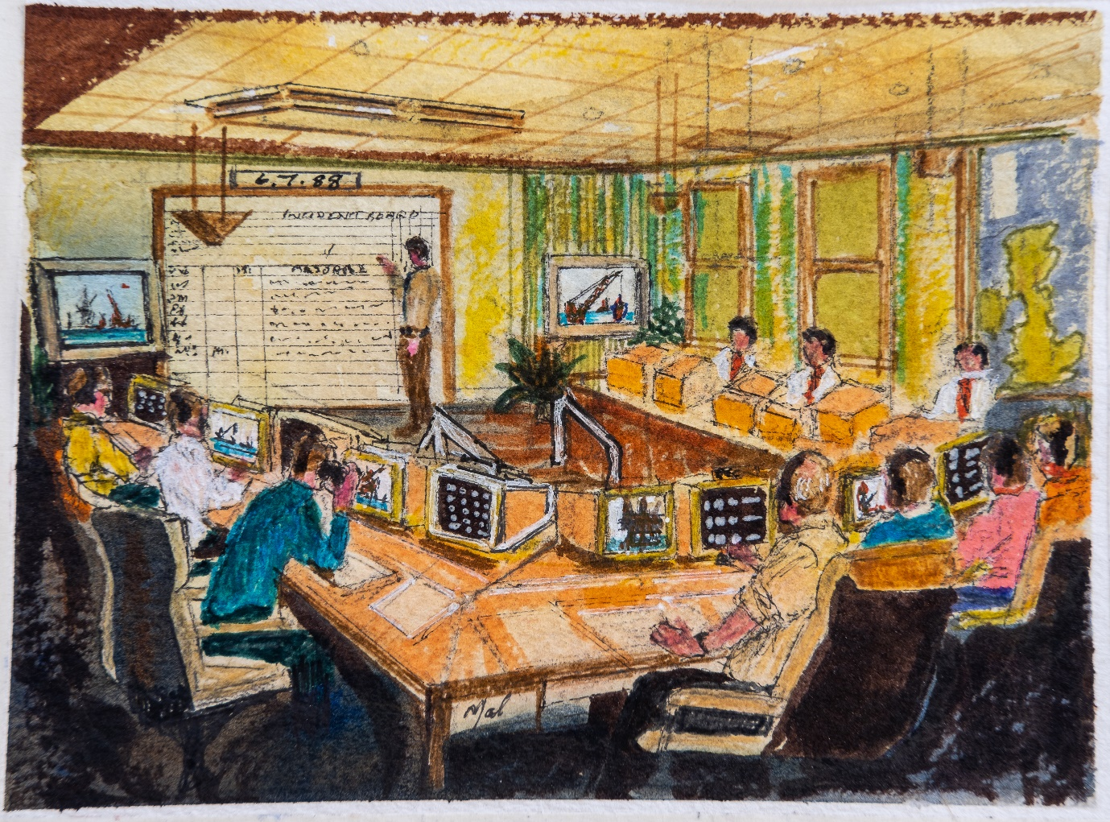
Our Emergency Response Centre in Aberdeen had global mapping 10 years before Google Earth.
On returning to Aberdeen in 1988 from the Middle East we revamped our Emergency Control Room into an Emergency Response Centre. (ECR to ERC). Although we didn’t know it at the time, we were following the principles in the Incident Command System that was being developed in California.
We commissioned Professor Mark Hansel of Cambridge University to establish the principles for the Centre. At that time, we had developed an accident incident Database called CARE. WE were collecting more than 30,000 accidents from 25 offshore installations involving 35,000 workers. In order for people to interpret the database we developed one of the first Natural Language applications in the UK. We had also developed a system for tracking all offshore workers so that we had all of their personal details in an emergency.
The ERC consisted of ten workstations each of which had 2 displays. One of the displays was dedicated to establishing communication links without the need to dial numbers and the other was for transmitting images (maps and diagrams). During an exercise it took us two hours to find a map, so it was necessary to get a mapping system. We found we could scan maps and link the scanned sections together. We developed a Multimedia Emergency Response Management Information System MERMIS for the North Sea and presented it to bp’s CEO John Browne. He immediately accepted our proposal. However, he wanted it for the whole world. As a result, we bought a copy of every map and mariners’ chart in the world from Stanford’s (London’s West End). We scanned and linked the entire globe over the next year. In 1991, This gave us an Analog version of Google Earth almost 10 years before Google launched their digital system. We had integrated all the elements of the incident command system by 1992 and published a paper in the Petroleum Journal.

Scotland Woodhill Lumphanan
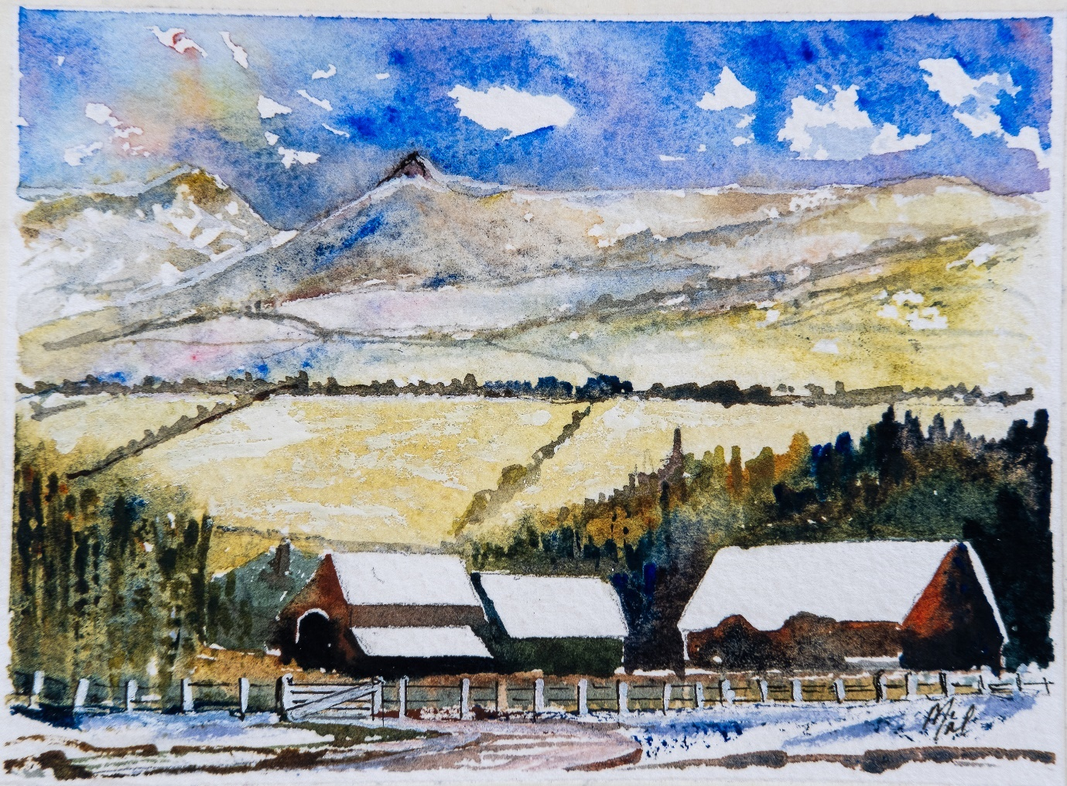
Locals call it ‘Centre of the universe’ it certainly was during the ’Northern Lights.’ Nov 1992
We arrived home from the Middle East on the day the stock market crashed it was also the night of the great storm in the South of England. A huge glass window blew out in the night and landed unbroken on us in our bed. We were lucky our roof didn’t come off. A short time later we transferred to Aberdeen to live in Woodhill at Lumphanan. Locals called it the Centre of the Universe. To be honest it was one of the most beautiful places I have ever lived. Woodhill was built in granite blocks; you could see for thirty miles from the front windows without seeing another house.
Lumphanan gave us the opportunity to explore Scotland and the outer Isles. We thought we’d be there forever. However, in 1992 John Browne offered all staff the opportunity to leave with a generous settlement. So, at my fiftieth birthday I took early retirement. After several months I needed to work so I applied to the Northern Colleges to teach Computer Science. I had worked with professor Donald Michie on artificial intelligence applications and had 22 years in computers with BP. At the interview I was asked for my Scotvec 2 module. I explained I was from Wales and did not have one, so my application was rejected. An ex BP colleague at The Robert Gordon University heard of this and arranged for me to apply to the University. I was accepted as a lecturer and found myself working harder than ever writing an Offshore Engineering course. During the first week of the course group of us were looking at the notice board. A colleague said.” I see you’re on tonight Mal”. I was shocked and said no one told me about this. Yes he said “ we all have to do one night a week. “What am I supposed to be teaching I replied”, his reply was,” The Scotvec 2 module.

Kuwait Mina Almahadi Refinery
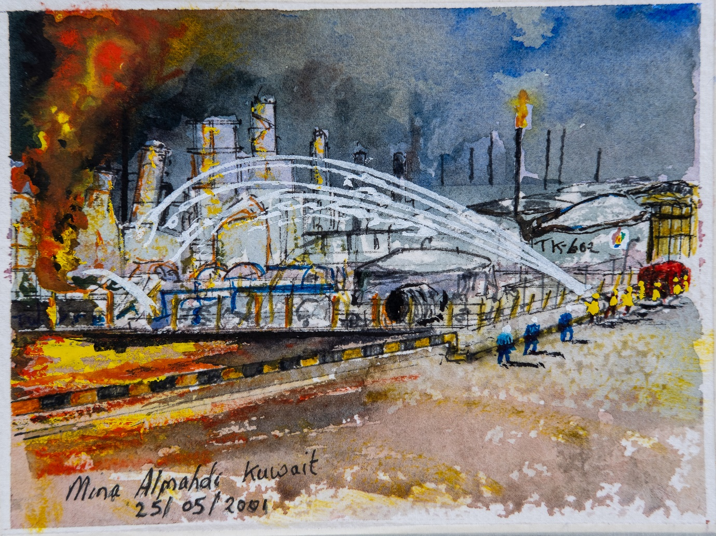
During a course in Kuwait firemen and production teams recall stories of a massive explosion
We left Scotland in 1994 and returned South where we eventually lived near Petersfield. The Hampshire West Sussex boarder ran alongside our garden. My employer Bechtel was involved in the work to suppress the fires which followed the war. In 1991 while presenting an Emergency Response course in Kuwait to operators and fireman from the Mina Alamahadi Refinery a debate broke out on the cause of a major explosion at the refinery. Eventually Fahad the Fire Chief took the floor and explained what had happened.
Fahad was called from bed 4am a major propane gas leak had been reported. His fire service had responded, setting up hoses around the leak. As Fahad drove to the plant still speaking to Fire Control the whole sky lit up and the line went dead. The explosion threw a 30-ton separator vessel into a adjacent refinery 3 miles away. Fahad took command and over the coming hours got everything under control. All liquid fires were extinguished and gas fires left to burn.
By 9 am he returned to his office to take a break and gather his thoughts. Entering his office, he spun around his large Fire Chief’s chair only to find it ad been splintered by 10inch long slivers of glass, when the office window blew out. He would have perished if he’d been sitting in it. The incident was caused when a major pipeline feeding the plant failed. A young operator tried to isolate the gas by turning the valve spindle. This required 960 turns to shut down the valve. Unfortunately, he had selected the wrong valve to shut.

Sea Empress Milford Haven
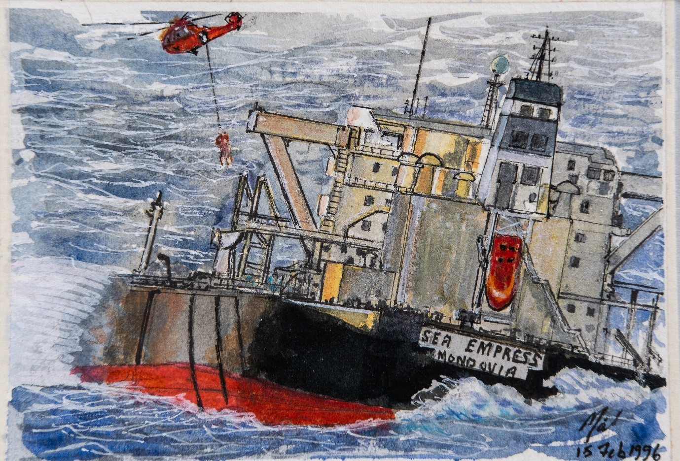
An oil spill exercise was about to start at Winchester when Sea Empress grounded at Milford Haven
In 1996 I took a job with COMAK near Winchester to avoid travelling to Bechtel at Hammersmith in London.
We were tasked with producing a video of the annual emergency response exercise for Hampshire which was to be held in the Emergency Response bunker at Winchester Castle. The exercise scenario was an oil spill in the Solent. Everyone associated with the incident duly gathered at the bunker at 7,30 am. The exercise was scheduled for 8 am. The director got the attention of everyone present and told them a major incident was occurring at that moment at Milford Haven where an Oil Tanker was adrift spilling oil into the sea have hit the rocks as it tried to enter the Haven in a major Storm/ The director offered to cancel the meeting so that people could offer immediate assistance. The delegates discussed the situation and decided to continue with the exercise. This was the first time everyone had worked together so it gave everyone a chance to get to know each other and their working practices. They would travel next day and organise the clean-up and whatever else was needed.
During the incident the tanker the Sea Empress was towed outside the harbour (A very controversial decision) and ended up spilling oil they took 9 months to clean up. The doodle illustrates a bizarre situation that occurred. It shows Sea Empress on the rocks spilling oil and a terrified Chef from the Milford Haven Chinese Restaurant being lowered by helicopter in a force 9 gale onto the deck of the ship. No one on the tanker could speak English.
A year later we visited St Anne’s head which was nearby to see the damage from the oil spill. Remarkably there was no trace of the sill.

Bechtel Jamnagar India
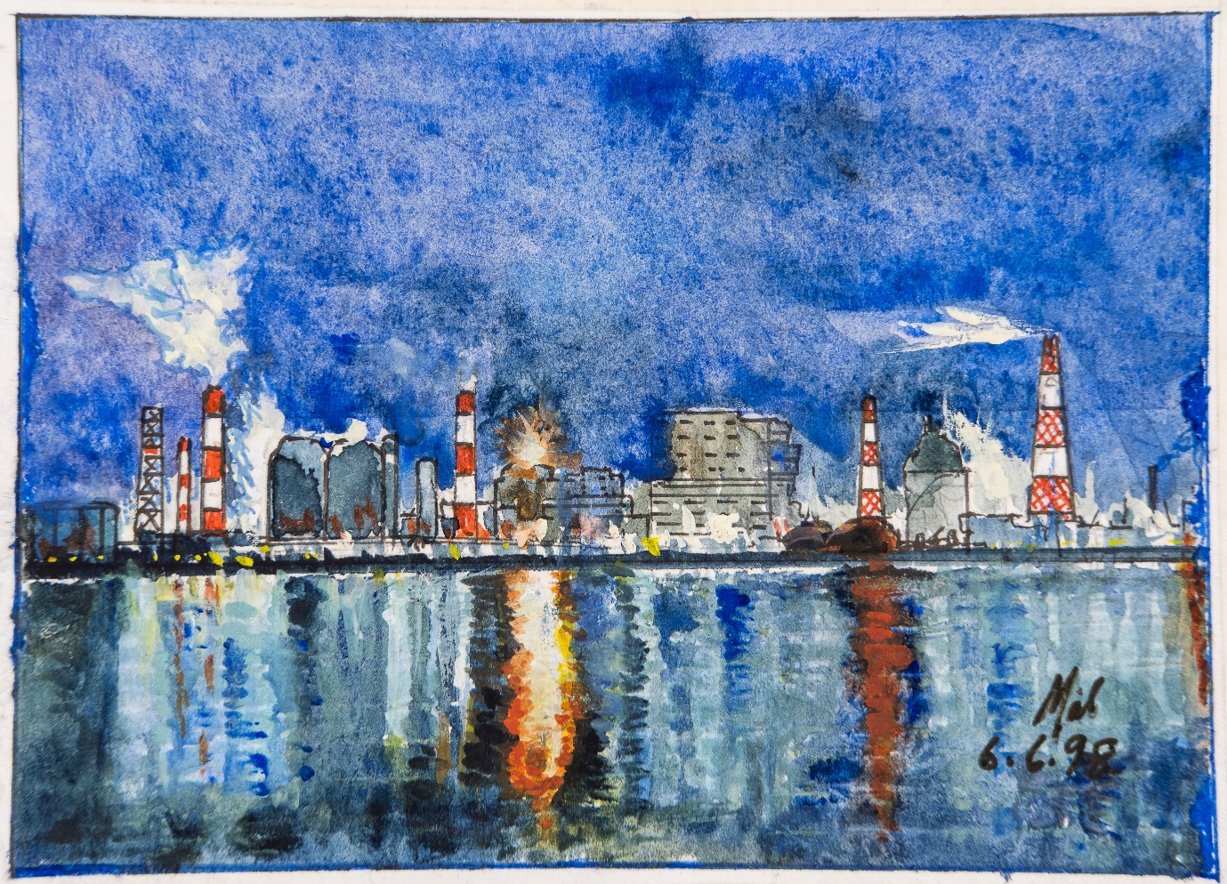
We built a simulator for the worlds largest Petro-chemical complex at Jamnagar, India
Later that year our division at Comak was told it was going to be closed down. I was told I was going to be made redundant with one months’ pay. As I returned from the meeting to my desk the telephone rang. It was a section leader at Bechtel, he asked me if I knew anyone who could build a refinery plant simulator. I explained my situation and he told me to apply for the job immediately. I started with Bechtel the following week and got paid twice for that month.
We spent several months writing the specification for a simulator for Jamnagar Refinery and selecting a suitable contractor. We were told that we would have to present the programme to the owner of the refinery Mukesh Ambani who was the 10th richest man on the planet. The contractor and I arrived outside the main board room for the presentation which was expected to last an hour at 6 pm.
We were eventually called to present at 11 pm. Mukesh endlessly questioned us on exactly how the simulator would work on all of the plants which was the largest refinery in the world spreading over 24 square miles. Near the end of the meeting Mukesh asked the contractor to reduce the price of an item. The contractor refused saying he would have to sell his front living room to do that.
After midnight Mukesh and his party went to dinner, I drove to Petersfield. Next morning, I was at my desk by 8 am only to see Mukesh heading for the Board room for another day’s meetings. We were all astonished at how much he knew about the detailed design of his new refinery. I was told by the electrical contractor that there was enough heavy electrical cable to go around the world twice.

Bab accommodation and mosque Abu Dhabi
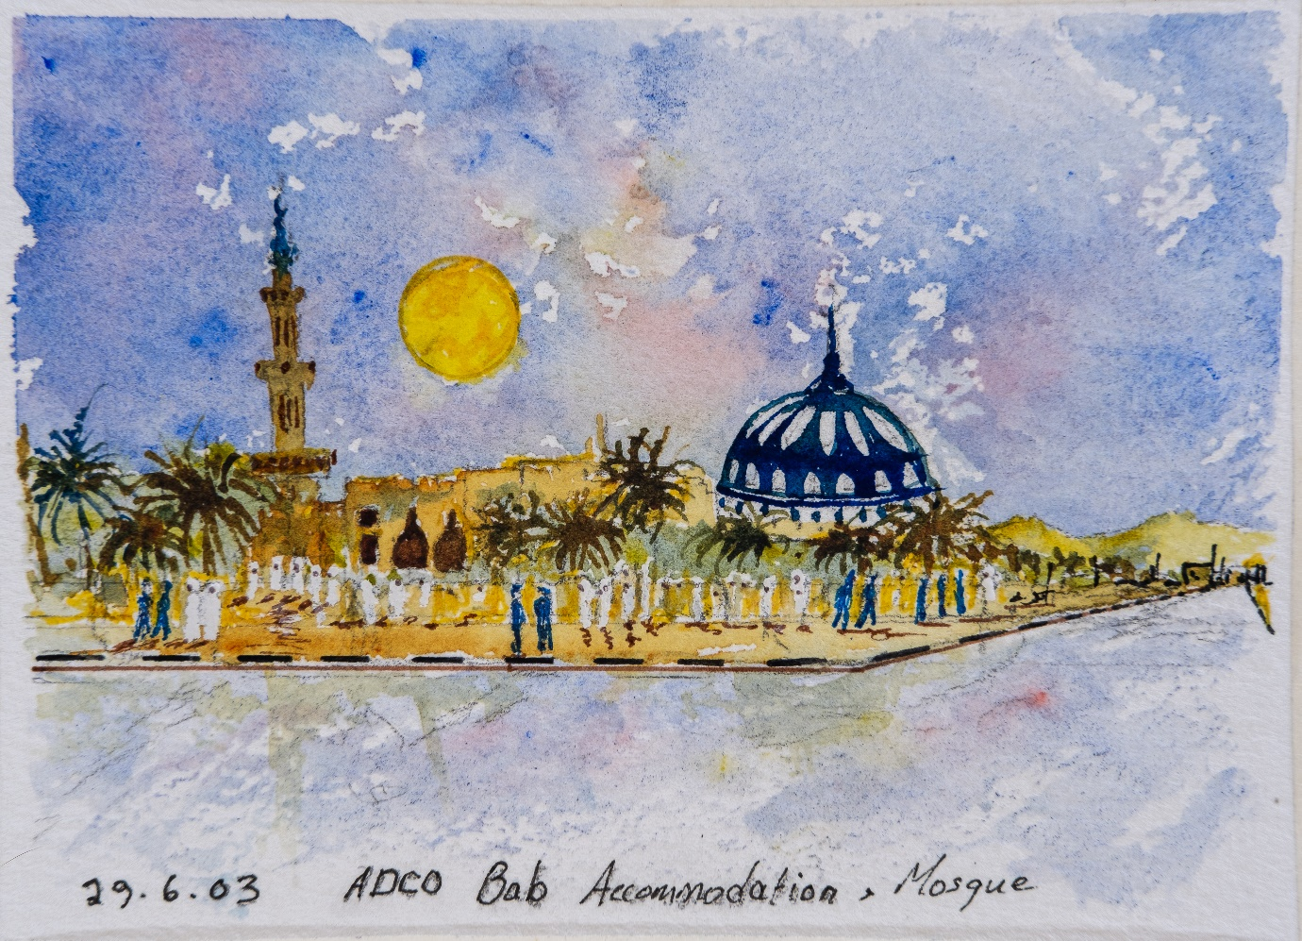
Bab accommodation was a delightful place to relax after a day’s work at desert sites
We were observers at the annual Emergency Response Exercise for the Bab Oil and Gas producing plant in the UAE.
The scenario involved a gas leak in a pipeline from the well head to the processing plant at an area where a village could be affected by the H2S in gas from the produced crude oil. (These were common occurrences (the pipes would get badly corroded relatively quickly and were regularly replaced.)
At the start of the exercise, the site manager explained that he had an urgent matter to attend to, so his deputy would take his place as Incident Commander. The manager then wished everyone well and left the room. The exercise got underway with the full incident command team and an on-scene command team sent to the incident site.
After twenty minutes the Site Managers PA came into the room and whispered into the Incident Commanders ear saying the Site Manager needs to see him urgently. The Incident Commander handed over command to the Operations section chief and left the room. The exercise was duly completed by the end of the day when the site manager returned with his deputy for the incident de-brief.
As far as the exercise was concerned everyone performed well and there were a few lessons learned until the Site Manager dropped his bombshell.
If you are in command of an incident you do not leave it and hand over command unless a more senior officer requests that he takes command. When you are sure that he is capable then you transfer command formally. You do not leave your post on any other pretext.

Oman Muscat

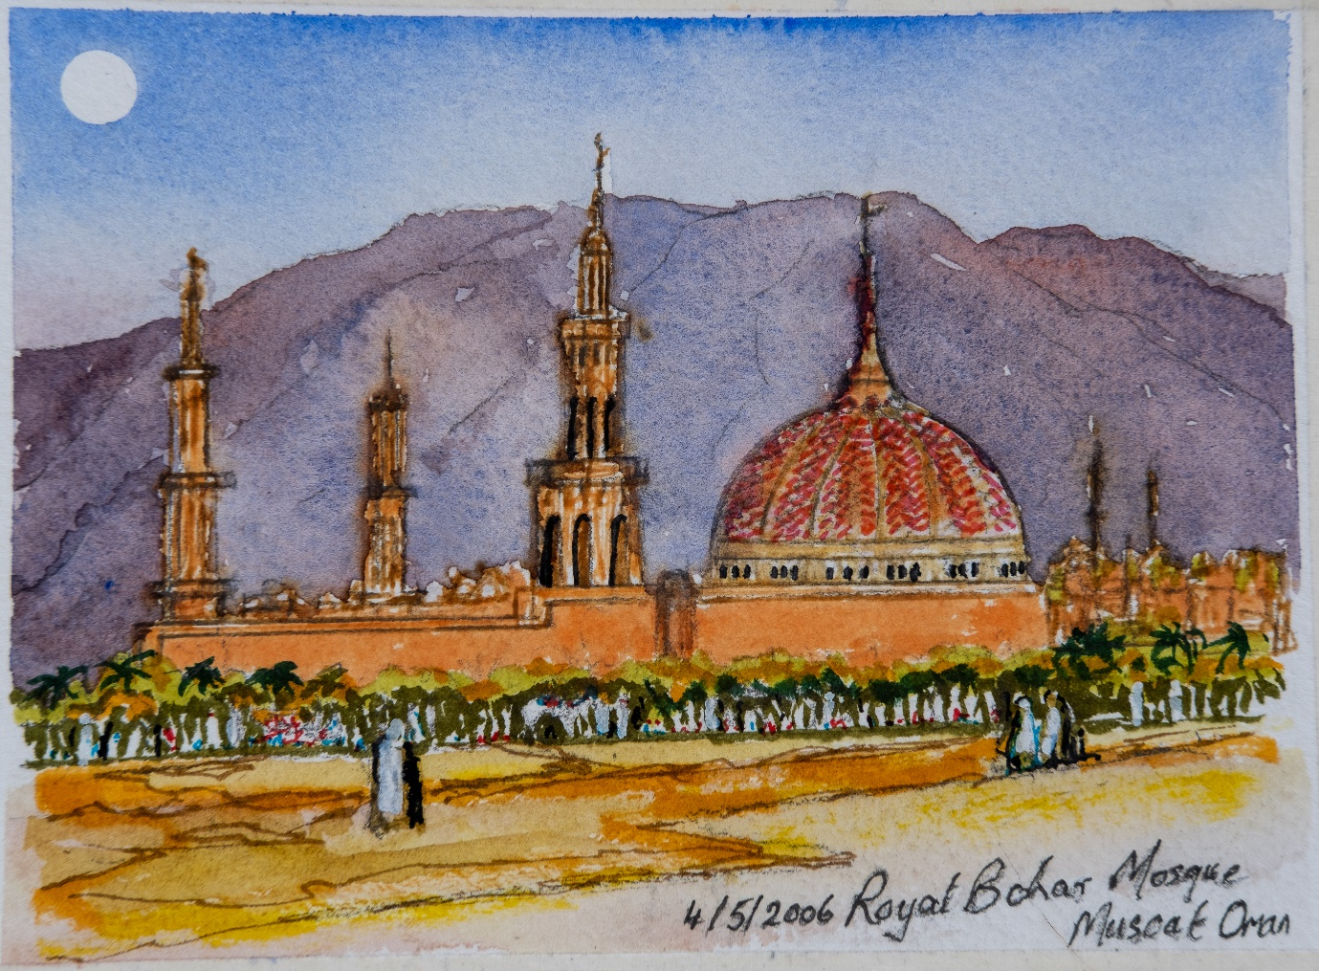
Communications are almost impossible when there are 47 languages spoken on site.
In 2006 I visited Oman where I had the opportunity to see their mosque and the ancient buildings at Muscat. I was told it was Sinbad the Sailor country.
I was there to review the Emergency Response facilities at a refinery in Oman, I spent 5 days with a Korean Emergency Response Manager. He was a good manager, who knew everything that was required. However, over the 5 days I had extreme difficulty in understanding him because of his very poor English. He would not have anybody translate for him as he was definitely in charge of all issues.
Subsequent to my visit, I heard that an incident occurred when the refinery was starting up a new Cat-cracking unit. During the night the process ran away and the catalyst which contained radioactive material was released to atmosphere. An Emergency was immediately declared and the Emergency Response Organisation was fully mobilized. The outcome was a disaster because the manager had insisted on approving all decisions which no one could understand.
The fallout from the cat-cracker landed on an ancient nearby village covering it in radioactive dust. This meant that the village had to be completely evacuated.

Houston Texas
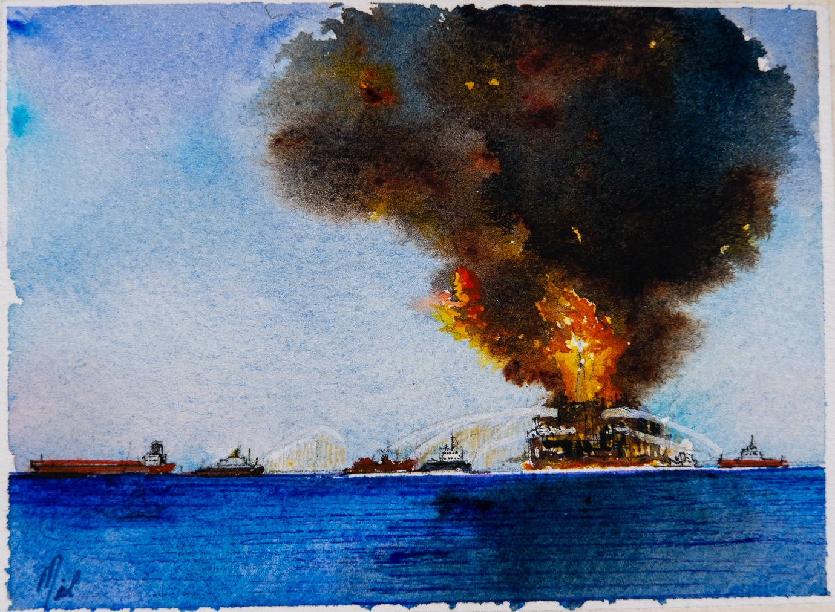
Over 45,000 responders involved at the peak, were needed to clear up this mess. 20/4/2010.
I visited Houston on several occasions on a variety of projects with Vosper Thorneycroft. The Doodle depicts the worst Oil Spill Disaster in history where a blow-out occurred on the Deep Sea Horizon Drilling Rig. Like all other major disasters, it’s not just one thing that goes wrong, when a number of relatively thing all fail in sequence, it can lead to a catastrophe. Many years earlier a BP director was asked on the Forties platform what the difference was between a disaster and a catastrophe. He replied, If the Oil minister visited our platform, and slipped and fell over the side. That could be a disaster, If, we lowered lifebelt over the side and fished him out, that would be a catastrophe.
As soon as it was realized that the blow-out preventors had failed, the only way to stop the oil flowing was to ‘Kill the well’. This process involved drilling a new well and pumping heavy mud into the path of the blown-out well. This process takes 90 days, so there was a massive Oil Spill Response required.
BP’s response to the incident was impressive. At one stage there were almost 50,000 people mobilised on a wide variety of tasks cleaning up the mess. The cost to the company was enormous, it took many years to recover.
I was in our doctor’s surgery in Hampshire, where I went to log in my arrival on the touch screen. The screen had not been cleared down, I recognized Jed’s name on the screen as on old colleague from BP. I turned around and said to one and all. “Is Jed here?” A voice from the other side of the room replied “Mal, what are you doing here?” We hadn’t seen each other in 20 years. Jed was still working on the Deep Sea Horizon incident.

Al Dabbiyah Abu Dhabi
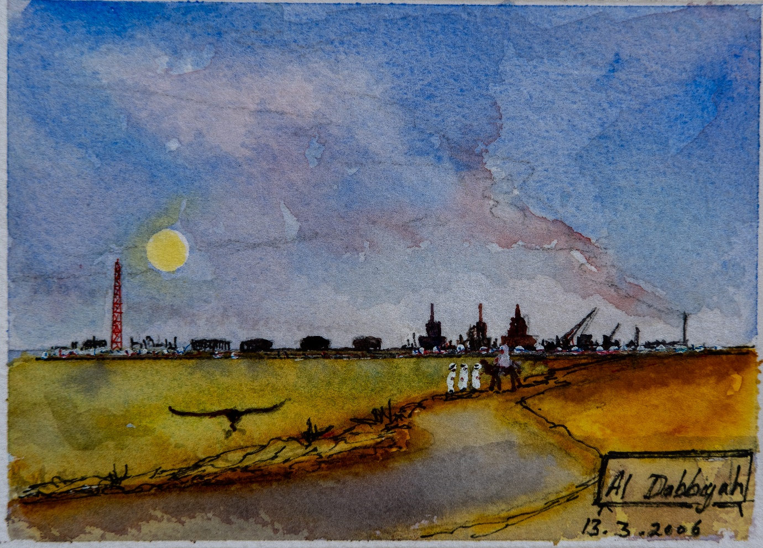
A two-acre field of grass was grown on top of recovered oil spills and oil spill waste. 13 March 2006
We were commissioned to write the Emergency Response Plans for virtually every Oilfield in Abu Dhabi. This task took us to many oil and gas production and drilling sites across the desert and on several offshore islands. We had an excellent host who accompanied us to all of the sites. On several occasions we travelled through the Liwa Valley between sites where I was amazed to see cornfields as far as the eye could see. Sheik Zayed also created tree plantation which were watered for hundreds of miles from Abu Dhabi City.
We visited one site where there had been an oil spill. The spillage had been cleared up and transferred to a research site some miles away in the desert. The Oil was spread out over an area the size of several football pitches. University researchers spread a compound over the spilled oil and planted a coarse grass seed. When we got there the grass had grown over the entire area turning the desert green. This spirit can bee seen in many places in Abu Dhabi where changes to the environment were truly remarkable.

Jebel Dhannah
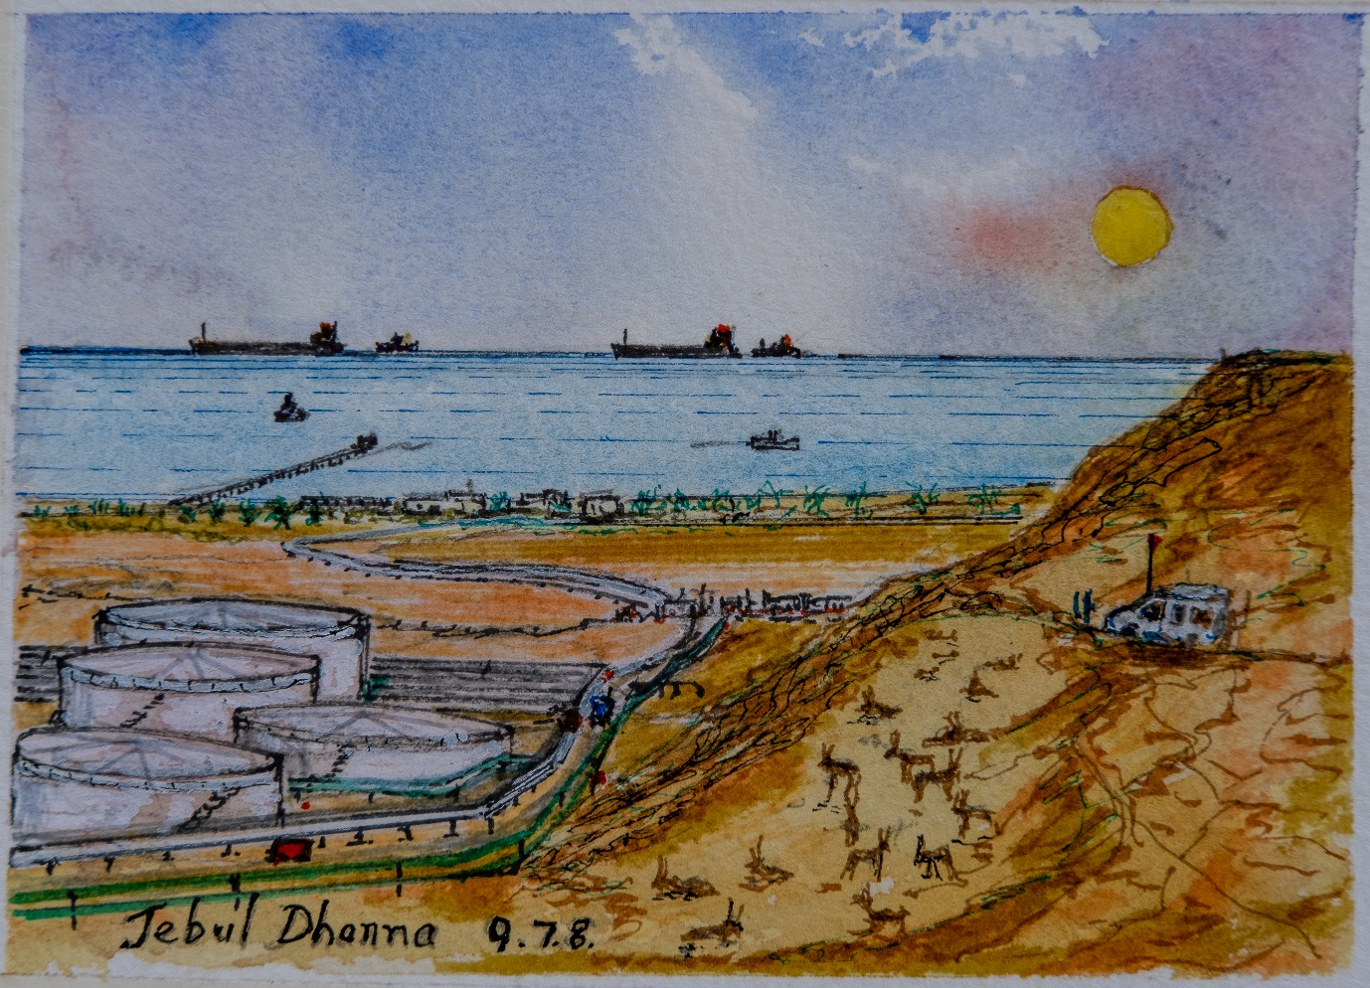
A herd of oryx stampeded as we drove to the hilltop. The whole horizon seemed to move.
We were asked to observe a major exercise for a tanker going aground at Jebble Dhanna terminal in the UAE. I had previously spoken to Captain Awad in Kuwait about bringing an Oil Tanker into Jebble Dhanna as he had been the master of a vessel that had made this journey many times. Captain Awad explained that bringing a tanker into the port at night was complicated as there were so many lights of many colours along the shore line it was not that obvious where to set the course. Very experienced Pilot are always on board the crude oil tankers at Jebble Dhanna before they are allowed to enter the port, as the narrow channel into the port has a dog leg which is very familiar to pilots.
In the scenario we had prepared a cement barge had sailed across the tanker channel and had sunk blocking the channel. An incident similar to this had happened earlier in the year where the cement barge narrowly missed the channel. (The cement barges were not as well-regulated as they might be as they were local traders.)
The exercise was called to order with everyone prepared for action. After an hour’s delay the Incident Commander entered the room. He thanked everyone for coming and declared that the exercise was over and very successful. (Nothing had taken place).

Dasman Institute Kuwait – a nurses’ story

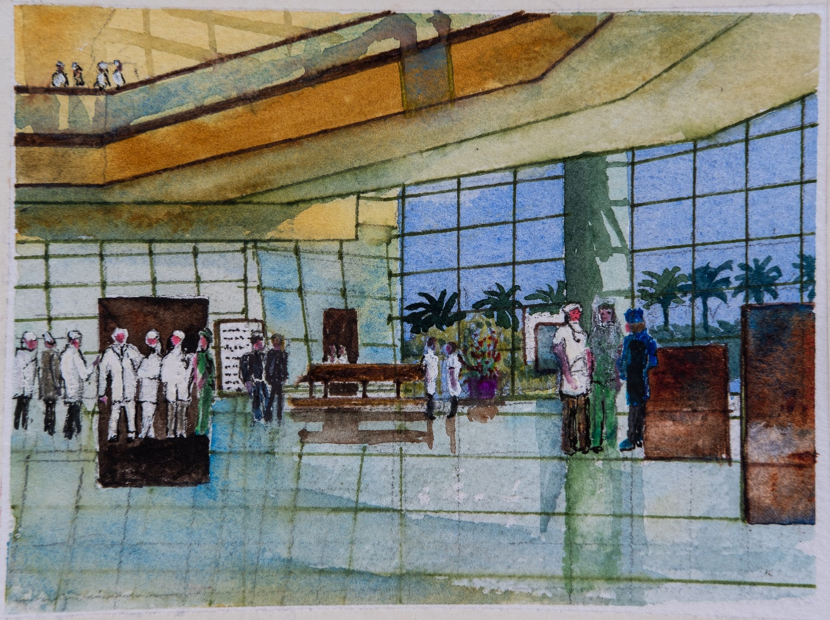
A nursing director at the Dasman Institute recalls a tragic incident during a Beirut air raid. 23/9/2016
A hospital in Beirut. A Nurse’s story from a course at the Dasman Institute in Kuwait.
“We were on duty at the hospital in Beirut when we heard the air raid sirens and immediately took cover. I Question:” Surely the hospital would be safe you must have identified it well with red crescent signs? Yes of course her reply, but that made no difference to the pilots because they suspected terrorists were being treated at the hospital.
The planes bombed us heavily for what seemed an endless period.
Question: What did you do then?
We waited until we were sure it was safe. Then we started getting casualties into ambulances to send to other hospitals in the city,
We were just about to send the last ambulance away when a young man covered in blood carrying his fiancé in his arms came running up to us. “Please let her in” he cried.
So, we managed to get her into the very last ambulance and send it away.
When I turned around to reassure the young man, he had collapsed, because he was also badly wounded from the shrapnel.
His fiancé lived, but sadly he did not survive.”

Egypt

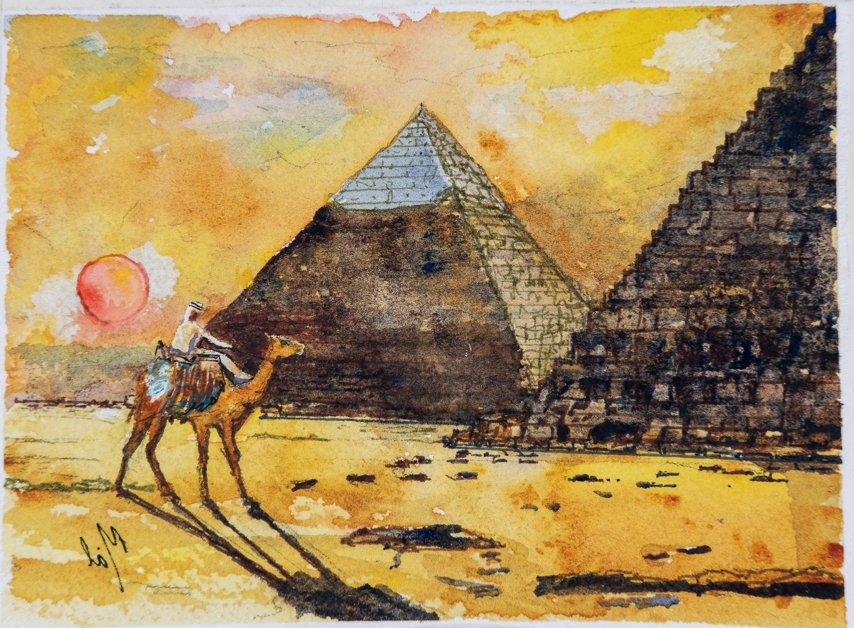
Years after completing a course in Cairo I found I had fractured my skull leaving a pyramid. 6/6/2009
During a visit to Cairo I was fortunate to visit the Pyramids at Giza in Cairo and the Pyramid of Djoser, which is a majestic limestone structure in the heart of a Pyramid Complex of Saqqara, the Pyramid of Djoser, it is one of the most renowned archaeological sites in the world. The pyramid was constructed 4,700 years ago during the reign of Pharaoh Djoser, one of the Third Dynasty kings that ruled over ancient Egypt.
Before Pharaoh Djoser took the throne, kings were typically buried in Abydos. This tradition changed and the pharaohs were then buried near Memphis, one of the oldest and most important cities in ancient Egypt.
Pharaoh Djoser settled on Saqqara which was then a large mortuary complex northwest of his capital city Memphis. The Egyptians built the Pyramid of Djoser — also known as the Step Pyramid — in the king's honour at the heart of the Saqqara necropolis.
We entered the Pyramid via a long tunnel to see its magnificent chambers.
On leaving the pyramid, I ran the top of my head close to the ceiling of the tunnel. When I reached the entrance, I did not notice an angle iron across the top of the doorway, it almost knocked me unconscious. Many years later when I had to have an MRI scan, I found out that I had actually cracked my skull.

Shanghai
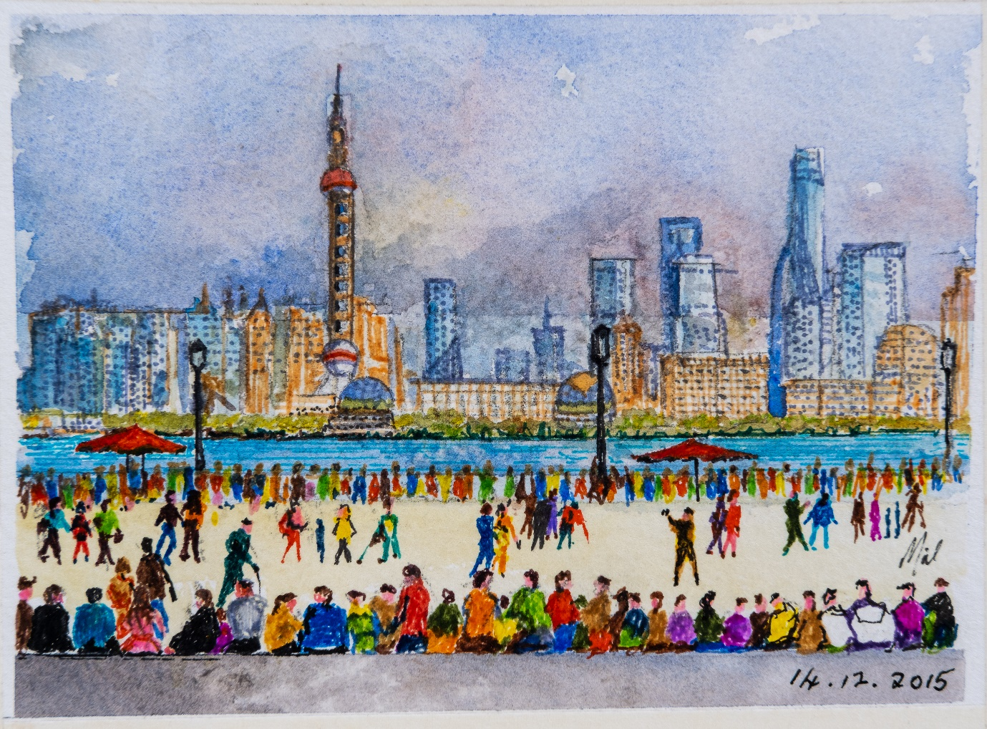
I tried to make a PowerPoint presentation using a Chinese Laptop – very challaging.
Shanghai was an interesting place to present a course. On the first Morning I was presented to the class following introductions I connected up my new Dell Laptop to the projection system. The New Laptop only had an HDMI cable Link. The lecture projector only had a VGA adaptor connector so I am in front of 30 delegates in Shanghai unable to present my course. I had all of my material backed up on hard disk, so one of the delegates lent me a laptop which had a VGA connector. After a few minutes the delegate had my hard disk linked to the laptop with the first Slide displaying on the overhead projector. I begin with the course ground rules, as well as the safety and break issues I offer a challenge to everyone to interact. I always present one of my paintings to the best interactive delegate. There must be more than a 100 paintings’ out there. To determine the winner, I list all the names on a flip chart and award stars to anyone interacting with me during the talks. One star for a question. 2 stars for a discussion, 5 stars for a personal emergency response story etc. When I did this at a course in Doha, the course Director said I thought you were mad, the CEO and many of his staff were delegates. I was amazed when the CEO joined the game, you could clearly see who knew the most. After the first slide I looked down to the keyboard to step on – Agh! The keyboard was in Chinese. I had to get the delegate to step through the slides on the first day – that was well worth 10 stars. By the next day they had procured an HDMI adaptor to connect my laptop to the overhead projector. I always make many friends on the courses. The doodle is of the Bund in Shanghai where we all had a dinner around a massive rotating table.

Dusit Thani Hotel Dubai
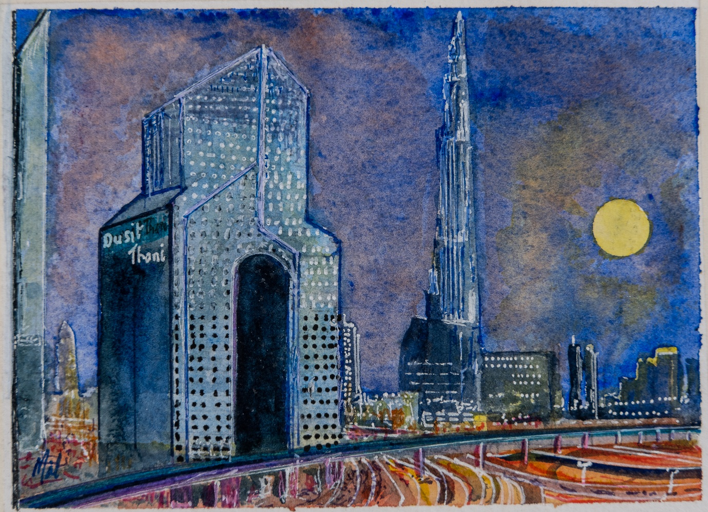
Watching a skyscraper city grow around the Dusit Thani hotel over a 10-year period. 5 Nov 1017
Many of my training courses were held at the Dusit Thani or Kempinski Hotels in Dubai I stayed in the Dusit Thani shortly after it opened and stayed their once or twice a year over the next 10 years watching a city of sky scrapers grow around it. In the doodle is the Burj Khalifa which I though would make a good sketch. After an hour or so a security guard asked me if I had a licence to draw it. When I replied in the negative, he confiscated my sketch.
We held an exercise in the Kempinski hotel where the scenario was an attack on the Mall of the Emirates that was just outside the hotel. The delegates who enjoyed the exercise advised me to take it to the Mall manager in case he could use it. That evening I did just that and found myself wandering around a massive Mall wondering how I could find the managers office. As I approached Debenhams, I saw two people in the entrance. One was in National dress and the other in smart white shirt and black trousers. I approached them and asked if they might know how I could find the managers. ‘Its me’ came the reply from startled man in black trousers. ‘This here is Majid who owns the Mall’. We were all startled by the coincidence, they both found it amusing if not uncanny.

Worms Head

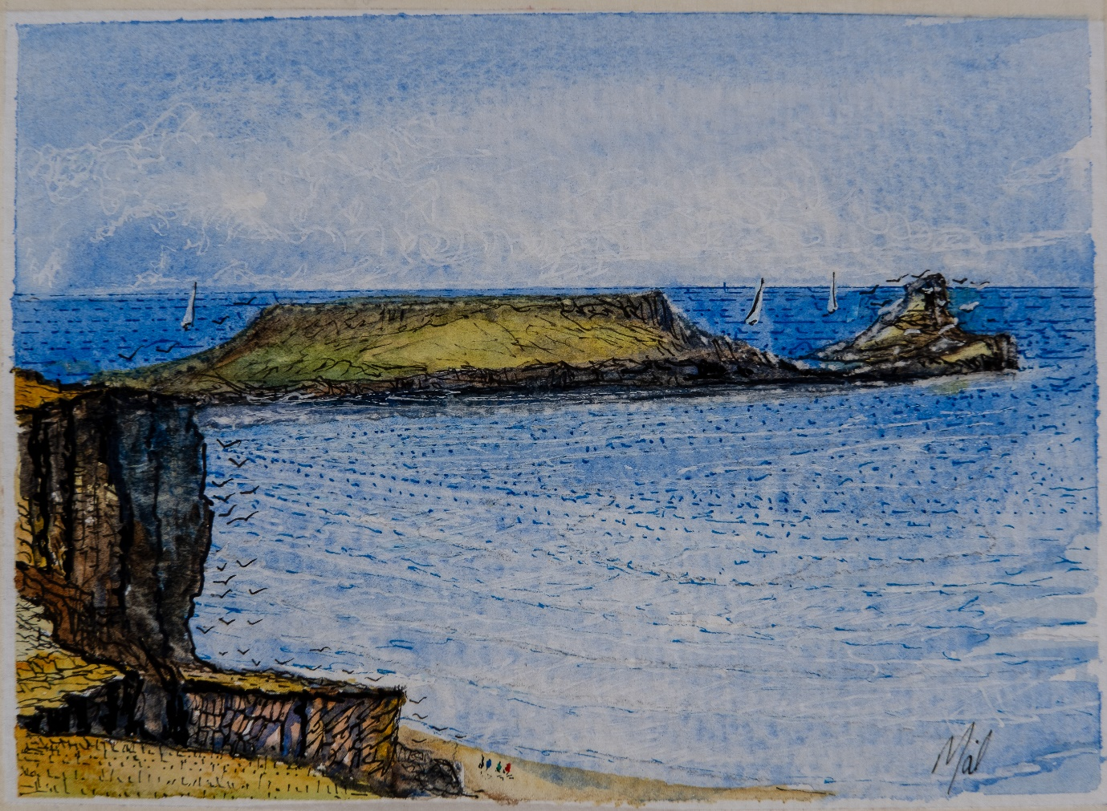
This doodle shows Worms head at Rhosilli on the Gower Coast. This is the last doodle it’s the place we wish to scatter our ashes.

